استعيني بالله ثم أجيبي على جميع الأسئلة

Q1: Comprehension

4
Read the following passage and answer the questions :
Penguins are birds. They can't fly but they can swim in the sea. The mother has one egg every winter. She gives the egg to the father then she goes to the sea for food .The father keeps the egg warm on his feet. After two months the chick ( baby penguin ) comes out of the egg.

A: Answer these questions:
1- How many months the chick baby comes out the egg?
.........................................................................................................................
2- Does the mother go to the sea for food ?
…………………………………………………………….

2

B - Write T ( true ) or F ( False)
- Penguins can't fly ( )
- The mother keeps the egg warm on her feet. ( )

Sea – birds

C - Complete with these words:
- Penguins swim in the ……………

2
- Penguins are …………………..

*****************************

follow
Q2; Information Questions:

6
1 – What is your name ?
……………………………………………………………….

2
2 – How old are you ?
………………………………………………………………..
B : choose the correct answer :
1- Hello , I'm Rami .
a- How are you b – Nice to meet you Rami . c- Good morning .

2
2- Jaber and Mazen are Samir's
a- uncle b – sons c- wife
3- How are you ?
a- I'm cold b- I'm tired c – I'm fine, thanks
4- What's the day to day ?
a- It's cloudy b- It's Sunday c – They are six
*****************************
C: Write the numbers :
1- 5 …………….

2
2- 20 …………….

D : P ut T or F :
1 – K areem and Jaber are friends ( ) .
2- Rami is Jabers brother ( ).
************************************

follow
3: Grammar :

5
A) Choose the correct answer s:

3
1- It is { a - an - the } orange.
2- { How much – How many – Some } people are there?
3- Tony , please phone { me - you - her } from the house .
4- Monsour { brush - brushes - brushing } his hair every day .
5-He is { is – are - am } a doctor .
6 – { Don't - not - no } eat that Kareem .
**********************************

2
B): Do as shown between brackets:
1- ? / kite / this / is / Whose /
……………………………………………………………………………………………………………………….
2- Can I go shopping ?
Yes , ……………………………. No, …………………….. (answer short answer )

***************************************
4: Vocabulary :
A: Circle the odd words :

2
1- water - sea - son .

6
2- cold - warm - stupid .
3- dessert - snack - school .
4- History - maths - shoes.
**************************************

follow

B: Choose the correct words:
Shark - idea - teddy bear - camera - English -

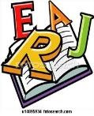
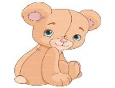
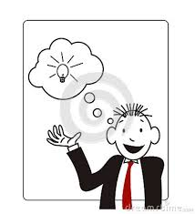

4

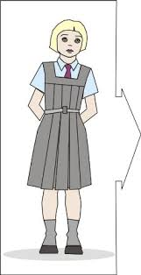
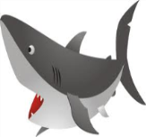
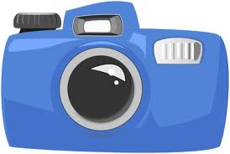
1-………………..…….. 2- ……………………….. 3- ………………………..

4-……………………….. 5- …………………………….. 6- …………………………..

********************************
Q5:Orthography :
A: Complete the words :

4

2
1- Mum and ……………..
2- Brother and …………….
3- Husband and …………….
4- Aunt and …………………
*************************

follow
B: Choose the right spelling :
1- money - moyne .
2- ckae - cake .

2
3- library - brarily.
4-art - tra .
5-sports - ports.
6- lobeg - globe.
7- lap top - top lap.
8- ath - hat .

***************************
Q6: Hand writing :
A: Copy the following :

5

1- We love our families.
……………………………………………………………………………………………………………………………………………………………………………………………………………………………………………………

2-God protects our country.
…………………………………………………………………………………………………………………………………………………………………………………………………………………………………………………….

The end ..
T.Kholud Al-Blowi

