3rd intermediate school
45 minutes
Monthly exam 1438-1439
Kingdom of Saudi Arabia
Ministry of education
Bisha , Almatla school

اختبار الفترة الثانية الصف الثالث متوسط الترم الأول .
اسم الطالب: الفصل:

- Write a paragraph about your Trip : using the following words ( rock climbing – leave – hotel – rainforest – cheap )
................................................................................................................................................................................................................................................................................................................................................................................................................................................................................................................................................................................................................................................................................................................................................................................................................................................................................................................................................................................................................................................................................................................................................................................................................................................................................................................................................................................................................................................................................................................................................................................................................................................

(2) A) Choose the correct answer :

- I am ( read – reading – reads ) a book now .
- They ( are – is – am ) cooking a dinner .
- I will ( goes – going – go ) to school early tomorrow .
- It started to rain ( when – while ) we were driving the car .
- I eat ( a few – a little ) carrots .
- ( how much – how many – how long ) milk do you drink ?
- I don't have ( something – nothing – anything ) for lunch .
- I was looking to ( myself – himself – herself )
- Ahmad didn't feel well ( so – because ) his mother cooked soup for him .

B) do as shown between brackets :

- I need a little butter . (ask by using ( how much or how many)

…………………………………………………………………………………………

2-she is writing her easy . ( change into negative )
…………………………………………………………………….

3- Will he go to Jeddah tomorrow ? (Complete the answer)

No,………………………………………………..

3) A write the number under the correct picture :
1-pepper 2- chicken 3 – yogurt 4 - cheese 5- crab 6 – carrots 7 – strawberry 8 – shrimp

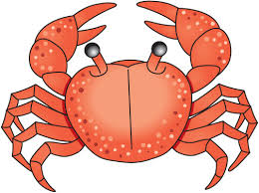
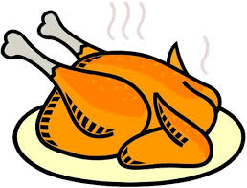
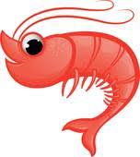

……. …… ……… ………. …… …….

B-Match with numbers:
1-I can't wait | ………….a-everything is organized
2-you guys | …………b-I usually grill it
3-everything is under control | ………..c-you can bake it
4-chicken | ………..d-you can fry it
5-eggs | ……….e- Im very eager for something
6-cake | ……….f-an informational way to address two or more people

انتهت الأسئلة
T/Wadha Al qhtani

10

