Kingdom of Saudi Arabia
Royal commission

Name:…………………………………. Class:……….



◊-change the following sentences to negative:
1- Ali likes swimming. …………………………………………………………………………………….
2- we like reading. …………………………………………………………………………………….
◊- choose the correct word :
1- Can Ahmad ( drive – driving – drove ) this car ?
2- Is he (called-calling-call) from Jeddah?

◊- write the time "in letters" under each clock face :
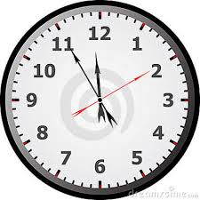
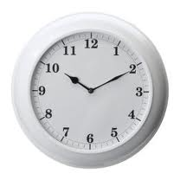

……………………………………………………………… ………………………………………………………………

◊- Answer the following questions:

1- what is he doing ? ……………………………………………………………

2- what is she doing? …> …………………………………………………………

◊- Copy : This is life

Best of Luck

