Name:……………………………………………………………………….. Class:…………………………………………………..
_____________________________________________________________________
Answer the following questions :
1-Name some important occasions are celebrated in your country? 2
………………………………………………………………………………………………………………………
2-Which jobs are more highly paid?
…………………………………………………………………………………………………………………………..
3-How many people go on Hajj yearly?
…………………………………………………………………………………………………………………………
_____________________________________________________________________
Q2: A-Choose
1-I was so ( nervous- dizzy – happy ) when my parachute opened.
2-I felt really ( terrified – relaxed – dizzy ) looking down at the beautiful view below .
B-Complete the spidergram with the words in the box :
Best man –certificate –scholarship-marriage-flowers - degree
Graduation
Wedding

……………………. ……………………….. ……………. ………………….. ………………………. ……………..

C-Rewrite the sentences using ( I wish ) :
1-The teacher was late .
………………………………………………………………………………………………
2-I didn’t have breakfast .
……………………………………………………………………………………………..
Q3-Grammar: Do as required in brackets:
1-Children ( have to –need – cant ) attend school .Its the law . (Choose)
2-If I ( had study – had studied – studied ) well, I wouldn’t have ( fail – fails – failed ) the science test . (Choose)
3-I wish I ( don’t leave ) my job . ( Correct the verb )
…………………………………………………………………………………………………………………………………………….
4-My brother's getting married ( at )Saturday morning . ( Correct the mistake )
………………………………………………………………….
5- ( Since – After – Before ) leaving school,my brother has had three jobs. (choose)
A-Circle the odd word :
1-Jacket / socks / whistle / trousers .
2-darker / colder / higher / heavy .
3-walk / stroll / stay / climb .
B-Write the correct word for each picture :
Wedding – Graduation – Abaya – Hajj – Doctor) (

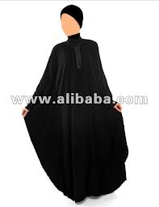

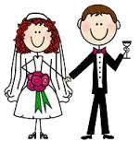
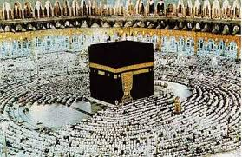


…………………….. ………………………. …………………………. ………………………………. ………………………….

best wishes for you
T.Houda

