
Revision Unit 1..Trends 2nd grade secondary

1- Describe the pictures by using two adjectives :

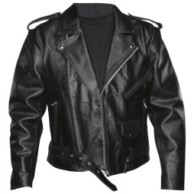
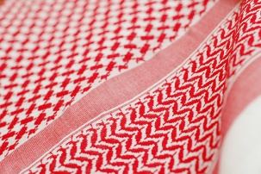
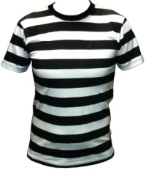
1- 2- 3- 4-

1-------------------------------------------- 2-------------------------------------------
3-------------------------------------------- 4-------------------------------------------

2- reorder the words :
a- shoes , pair , tennis , a , white , of
---------------------------------------------------------------------------------------------
b- gold , small , a , pair , earrings , of
---------------------------------------------------------------------------------------------
c- plastic , black , a , jacket
---------------------------------------------------------------------------------------------


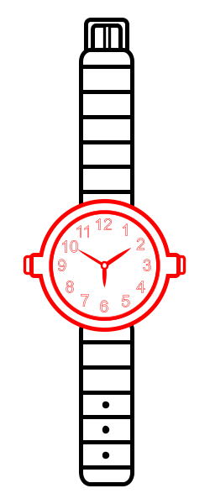
3- Choose the write word under the pictures :
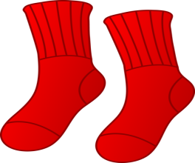
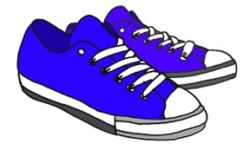

a-( socks – scarf ) b-( ring – watch ) c-( tracksuit- trainers) d-( monitor-mouse pad)



e-( scarf – tie ) f-( headband – sweater )

4- write the correct words under the write category :
( monitor – aftershave – ring – bracelet – keyboard – razor blades – tracksuit – golf club )

A – men’s toiletries : ------------------------------ -----------------------------------
b- computers : ------------------------------------ -----------------------------------
c- jewellery :-------------------------------------- -----------------------------------
d- sports :----------------------------------------- -----------------------------------

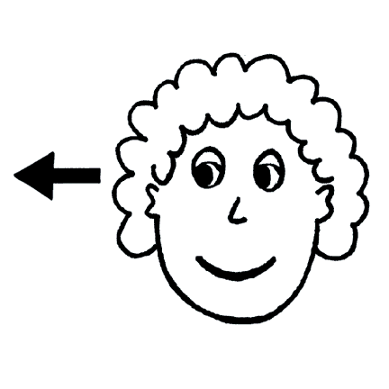
5-
Countable : many # few uncountable : much # little

Any – a lot of – some – most – all – none – neither – all of- both

Choose the correct answer :
a- How ( much – many ) people are coming ?
b- ( Both – All ) of my parents are Saudi Arabians
c- Can you answer ( a few – a little ) questions about the history lesson ?
d- There is not ( much – more ) water in the lake

6- Complete the table , comparing between the urban life and the rural life :
Urban life rural life
1---------------------------------------------------- 1---------------------------------------------------
2---------------------------------------------------- 2---------------------------------------------------
3---------------------------------------------------- 3--------------------------------------------------------

7- Complete :
a- We use ------------------------ , ----------------------------- and ----------------------------to
introduce reasons.

b- give reasons for the following sentences :
- I did not go to school yesterday ---------------------------------------------------------------------------------------------------------------------------------------------------------------
- I will travel to Makkah in Ramadan -----------------------------------------------------------------------------------------------------------------------------------------------------------

Prepared by
Teacher Bushra Assiri

