Complete the following:-
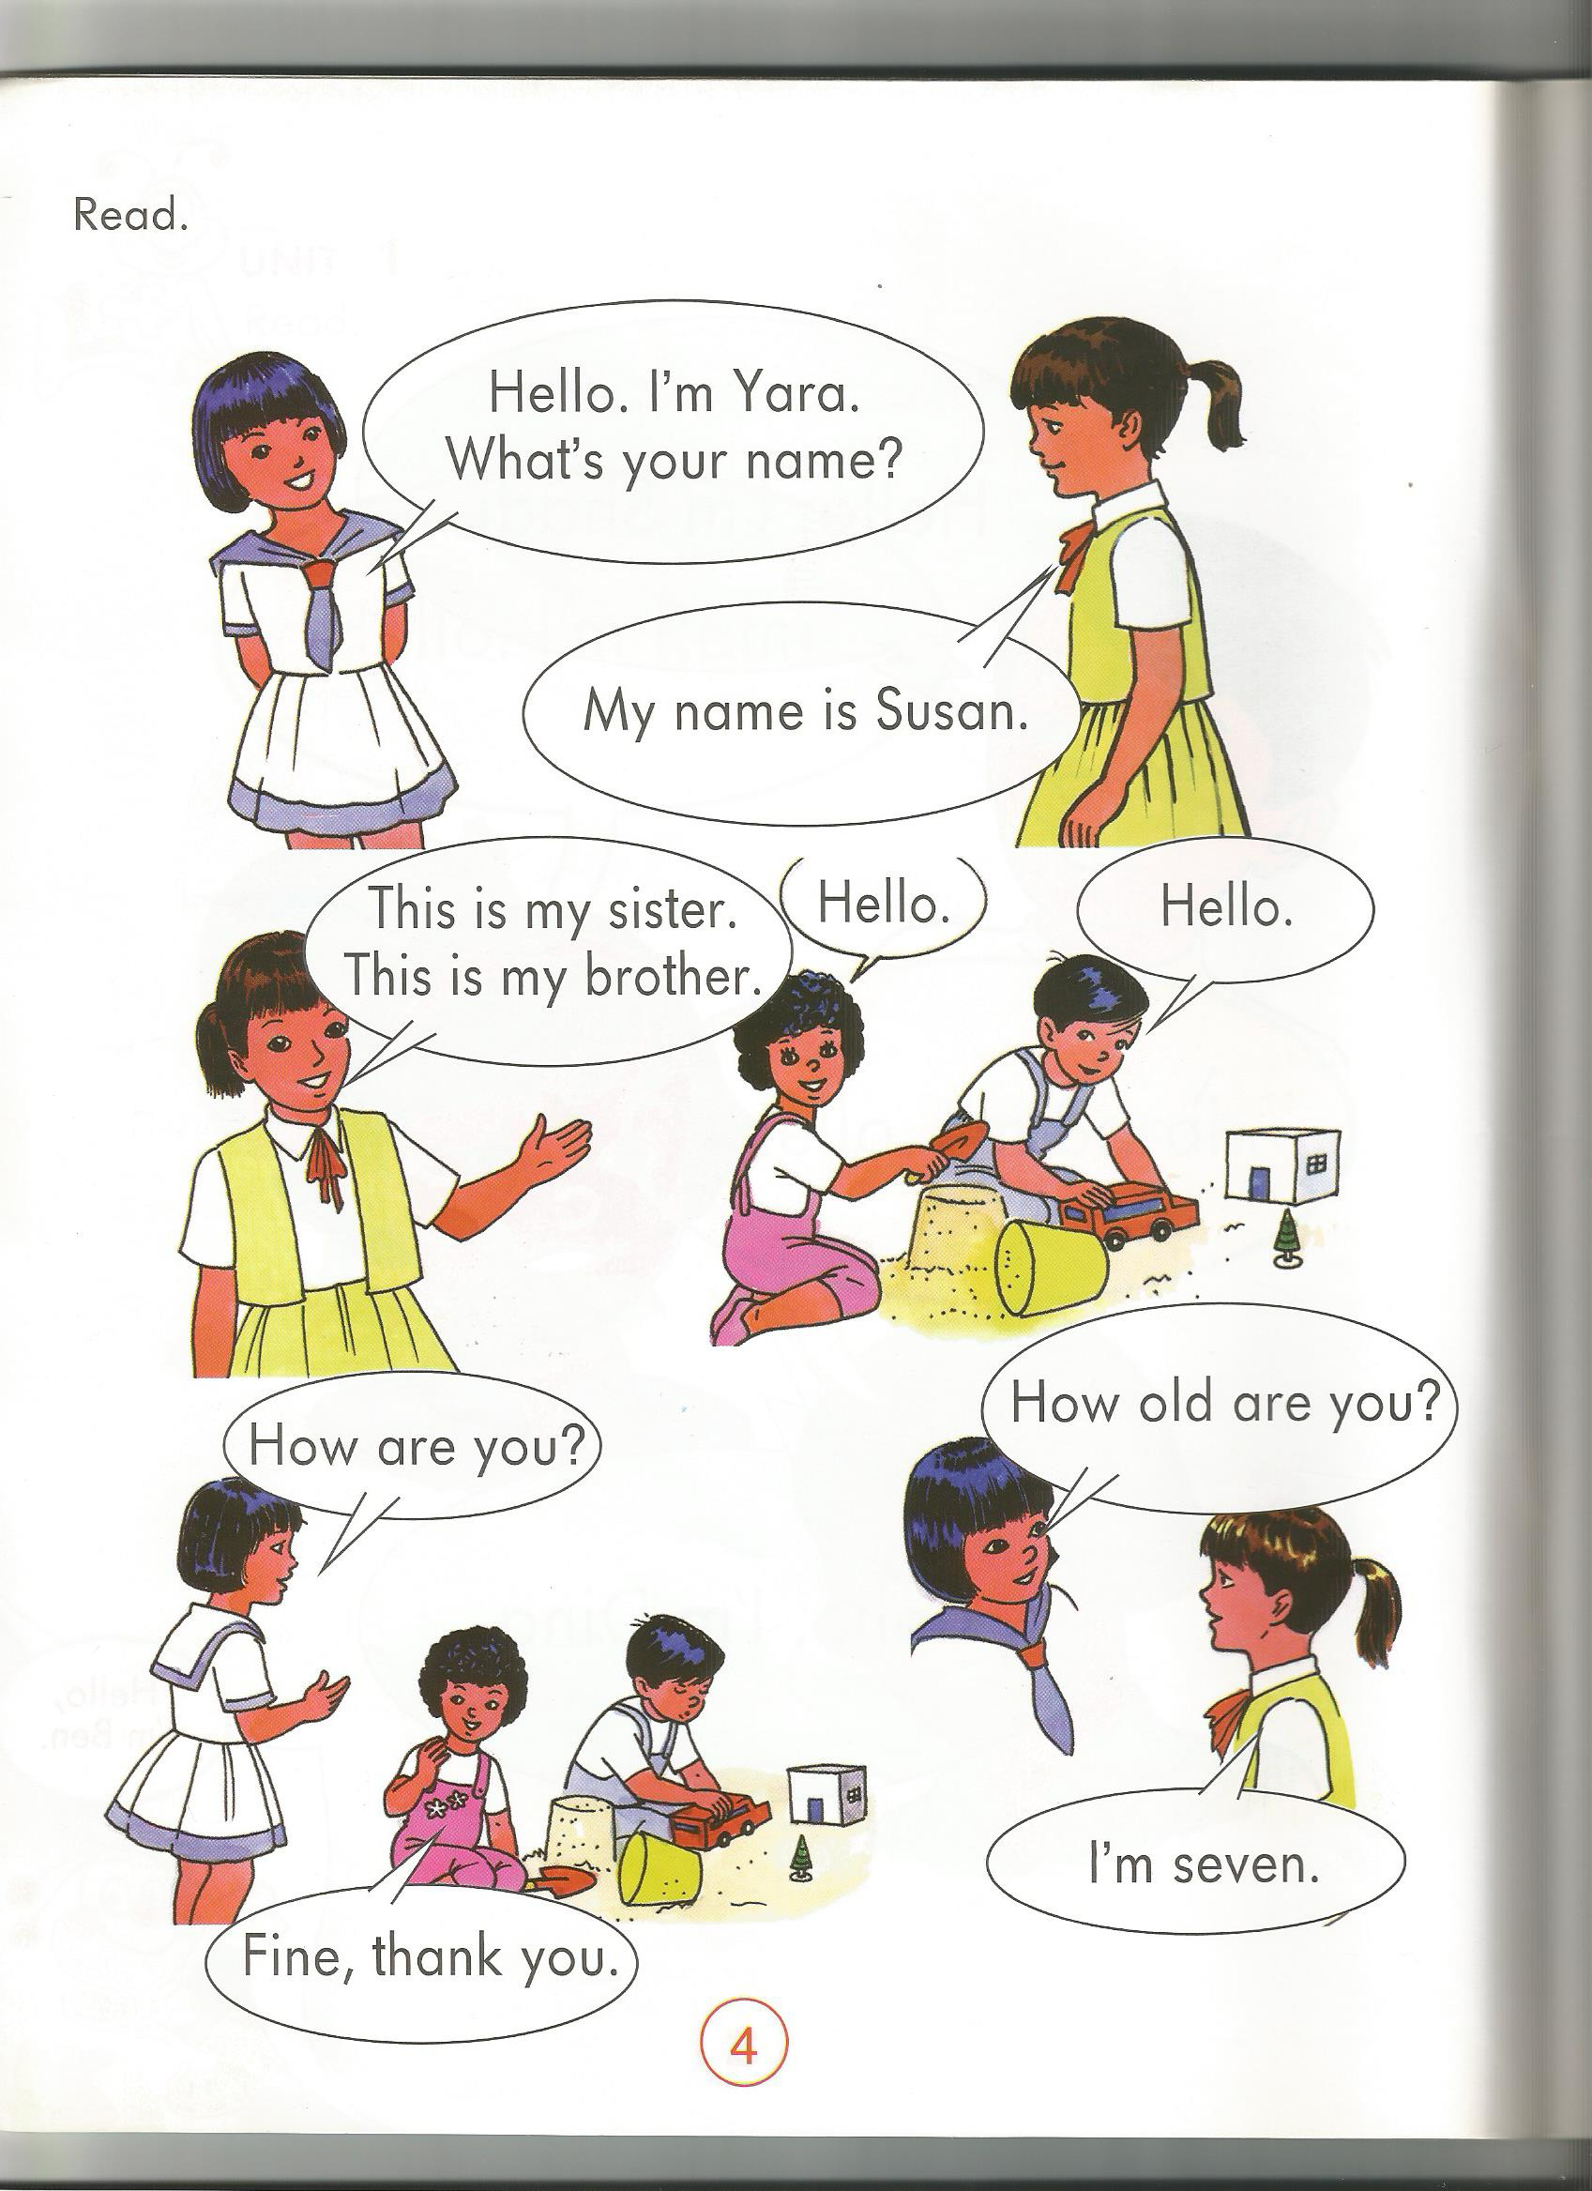

………….

……………………………….

……………………………….

It's …………………to……….you, Yara

………….

………….
I'm …...………….., ……….

