
Kingdom of Saudi Arabia Quiz module 1
Ministry of education 1st grade
A) Vocabulary
1)Complete with the suitable word:

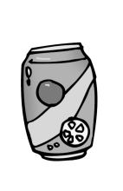
( cup – packet – can – bottle )


1-a of biscuits 2- a of lemonade 3- a of ketchup
2) put the word under each picture :
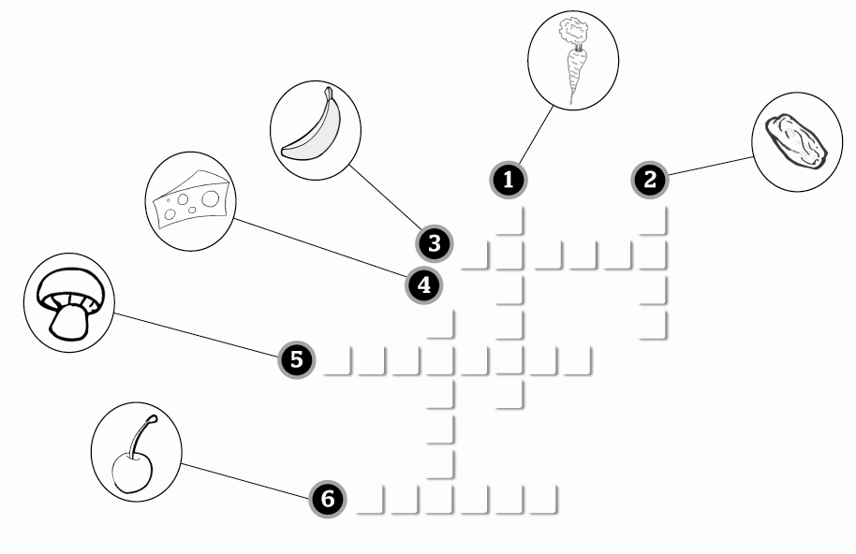
Cherries – steak – carrot – cheese – banana – mushroom)
B) Grammar
1)complete with a , an , some :
a- there's ________ orange and ________cherries in the fridge.
b-A: I want _____ lemon.
B: I think there are ______ lemons in the kitchen.
2) complete with ( how much – how many)
a- ______________ water do you drink a day?
b- ______________ apples have we got?
c- ______________ cups of tea does your sister drink every day?
3) use ( SOME – ANY )
Excuse me ,Would you like _________ apples ? yes, sure. Is there _______orange juice?
Sorry , we have not got ________ orange juice. Would you like _______ cakes for desert? No ,thanks.

