A

Name: …………………………………………….............. Class : …………. Mark : /10

- Complete the sentences with a phrase from the box below:
source – ocean waves – nuclear power – fossil fuels
- Oil and coal are both …………………………..
- ………………………….. produces radioactive waste, which is dangerous.
- Wind is one of the cleanest and best ………………………….. of energy.

- Circle the odd word and explain why it doesn't fit:
- windy / tree / sunny / cloudy ………………………………………………….

- Make a sentence about the picture below using going to and the words in brackets:
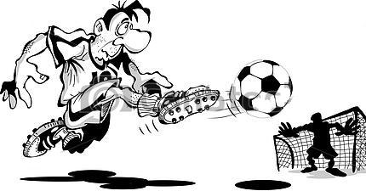
( he / score a goal )
…………… ………………………………………………………………………..
………………………………………………………………………..

- Use the words below to write a conditional sentence with if.
- we / not / go to match - it / rain
………………………………………………………………………………………………….
- Listen to a nutritionist talking about energy and then answer the questions below:

- What percentage of energy is used for :
- eating and digestion? ……………………..
- body function? ……………………..
- physical activity? ……………………..

- Where does our energy come from? ……………………..

B

Name: …………………………………………….............. Class : …………. Mark : /10

- Complete the sentences with a phrase from the box below:
renewable – fossil fuels – generator – wind
- Solar is ………………………….. energy.
- ………………………….. is one of an electricity- producing machinery.
- Oil and coal are both …………………………..

- Circle the odd word and explain why it doesn't fit:
- oil / windmill / gas / coal ………………………………………………….


- Make a sentence about the picture below using going to and the words in brackets:
( it / rain )
………………………………………………………………………..
………………………………………………………………………..

- Use the words below to write a conditional sentence with if.
- you / eat that cake / - not / eat launch
………………………………………………………………………………………………….
- Listen to a nutritionist talking about energy and then answer the questions below:

- What percentage of energy is used for :
- physical activity? ……………………..
- eating and digestion? ……………………..
- body function? ……………………..
- Complete
- our energy comes from …………………… which we get from different type of food.

