Work Sheet Unit (2 ) Big Moment .

Writing
1-Write some notes about an experience in your life that you cannot forget.
The first time I………………………………………………….
……………………………………………………………………………………………………………………………………………….
……………………………………………………………………………………………………………………………………………….
……………………………………………………………………………………………………………………………………………….
Vocabulary:
1- Write the correct word for each picture :
(Parachuting/ Ice-skating / Bungee jumping/Whitewater rafting/ Bicycle riding /Surfing)
 | 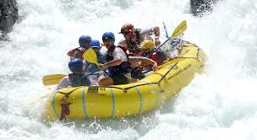 | 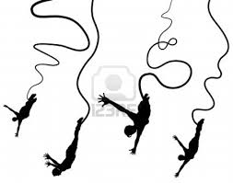
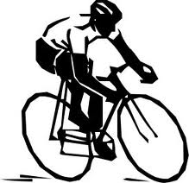 | 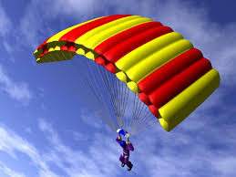 | 
Feelings
Relaxed
Happy
Dizzy
Terrified
Excited
Nervous

2-Complete the following sentences with the correct words:
- People are described as …………. when they have no worries or stress.
- Going without sleep for a long time makes me feel ……….. and light-headed.
- He huddled in the corner like a ……………… child.
- I was very ……………… about driving again after the accident.
- Are you getting .................. about your holiday?
- She looks so …………………with her son.

3-Divide the correct items into the correct categories :
University | Bride | Scholarship | Degree
Marry | Groom | Exams | Engagement
Graduate | Ring | Diploma | Limousine

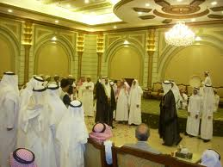  Wedding |   Graduation

Grammar:
1-Complete the sentences using the correct preposition.
1- ……………………… leaving school, He went home.

2- ………………………. doing the exercise, He read the instructions.

3- They watched the football match …………………..having lunch.

4- ………………………. watching TV, he has answered 3 calls.

2-Put the words in the correct order to ask for directions.
1-the / way / you / can / me / tell / to / house / Ahmad's?
………………………………………………………………………………………….
2-the/ library / can / I/ how / to / get.?
………………………………………………………………………………………….
3- your / school / is / best / the / way / best / what / to ?
…………………………………………………………………………………………

