Module ( 1 )
Name:…………………………………………….. Class:…………..

1} Speaking:
A) What is your favourite school subject?
………………………………………………………………………………..
B)What do you do in your free time?
………………………………………………………………………………..
C) What kind of clothes do you like wearing?
…………………………………………………………………………….….

2} Reading Comprehension:
Read the following comprehension then answer the questions below:
King Fahd International Stadium is in the astern part of Riyadh, Saudi Arabia. It is a football stadium, but athletic events also take place there. The stadium opened in 1987 and it can hold about 70,000 people. It's a beautiful stadium with a very clever roof. It keeps the sports fans out of the sun. King Fahd International Stadium is the home of the Saudi Arabian National Football Team and they play all their important matches there.
Answer:
1- Where is King Fahd International Stadium?
………………………………………………………………………………..
2- Are there athletic events in the stadium ?
………………………………………………………………………………..

Put ( √ ) or ( X ):
1- The stadium opened in 1988 . ( )
2- King Fahd International Stadium is the home of the Saudi Arabian National Football Team. ( )

Complete:
1- It's a beautiful stadium with a very …….…… roof. It keeps the sports fans out of the ……….....

3} Vocabulary
A)Write the right words to describe the clothes under each picture:
iron - hoover - shirt - skirt - gym
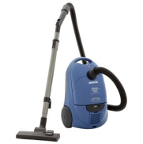

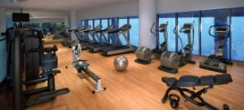
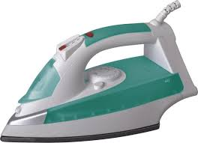

………………….…… ………………………… ……………….....……… ……………………….

B) Give the opposite:
1- outgoing $≠$…………………. 2- active $≠$……………………. 3- friendly$≠$……………………

C)Match:
1- chat - the net
2- surf - magazine
3- read - on the phone
4- download - out with friends
- information from the net

4} Grammar

A) Choose:
1- We usually have breakfast ( at – on – in ) 7 o'clock.
2- I am ( read – reads – reading ) a book at the moment.
3- Ali wants to ( watch – watches – watching ) TV.
4- ( I – Maha – Ahmad and Ali ) plays computer after school.
5- I like ( visit – visited – visiting ) my friends.

B) Do as shown between the brackets:

1- He ( go ) to school every day. ( Correct the verb)
……………………………………………………………………………………………
2- My mother / does / often / the washing up ( Rearrange )
……………………………………………………………………………………………
3- They play football every Thursday. ( Make it negative )
……………………………………………………………………………………………
4- She is sleeping now. ( Make Yes/No question )
…………………………………………………………………………………………...
5- I enjoy ( cook ) with my mother. ( Correct the verb)
……………………………………………………………………………………………

5} Dictation:
1- Choose the correct letter:
l – n – r r – f – p k – d – l
a) earri__g b) __ubbish c) hea__scarf

2- Match column (a) with (b) :
( a ) ( b )
jum ings
legg ers
chem ths
istry
6} Writing:
Write a paragraph about " My best friend "
- Say who your best friend is and how old she is. / write about her appearance
-Write about her personality. / write what do you do together.

7} Listening: Tr. Haifa Almogbil

