Review Unit ( 3 )
My Name …………………………………………………………………………………………………………………………………………..

Q 1: Write the correct word under each picture :

( percent - coins - pound – note – sale – calendar )
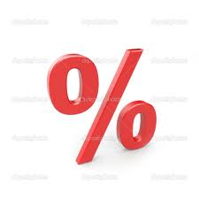
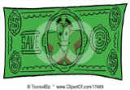
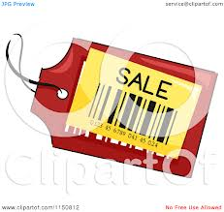
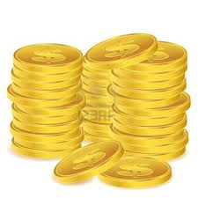

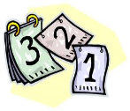

…….… ….…… …..…… ……... ………. ………..
Q2: Choose :
1- Five hundred and thirty - one ( 351 – 153 – 531 ) .
2-One hundred and sixty – four ( 164 – 146 – 461 ) .
3- I like ice cream very much . ( So do I - So am I )
4- I'm hungry . (So do I - So am I ) .

Q3: Choose :
1- Fred is ( small – smaller - smallest ) than Any .
2-The red car is ( expensive – more expensive – expensiver ) than the green one .
3- He has a car , ( his – her – our ) Car is new .
4- I'm Nada , this room is ( my – mine – I )
5- I don't have ( some – any ) dress .
6-Tom has got ( some – any ) books from the library.
7- They ( has – have – had ) got some works .

The European Monthe :
The months of the Year :


January - Febraury - March - April - May - Jun - July - August - September October - November - December .



