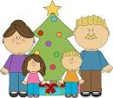
Revision Unit ( 2 )
My Name …………………………………………………………………………………………………………………………………………..

Q 1: Write the correct word under each picture :

( grandpa - computer - grandma - bell - carpenter – best friend - clever - sheep - farmer - vet - postman - waiter – pilot )
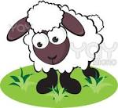






…….… ….…… ……. ……... ……… …………

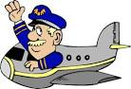
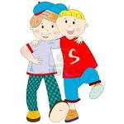

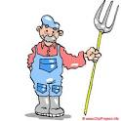
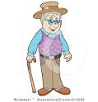


…….… ….…… …..…… ……... ………. …….. ……..

Q 2:Do as shown between brackets :
1- Mother = ………………. 2- grandmother= ………………… ( Give the other words )
2- family = ………………… child = ……………… sheep ………… ( Give the plural )
3- He's from Italy . He's ……………… ( Complete )
4- He's from ( Spain – France – Poland ) . He's polish . ( Choose )
5- watch – could – T.V – please – I . ( Rearrange )
6- mouse - monitor - doorbell – webcam . ( Circle the odd words )

