
English working paper


Name:
.......................
Unit: Hello
Lesson:1
Classroom:
........................
Activity:
.......................

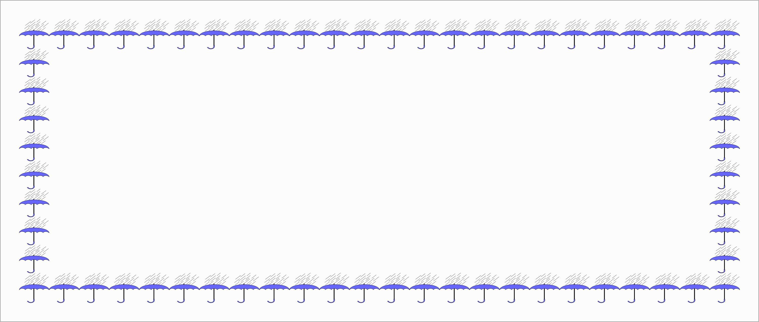
Match countries with nationalities:

Bahrain Spanish
France Egyptian
Egypt Bahraini
Morocco Moroccan
Spain French




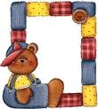
Match

Folder
Laptop
Dictionary
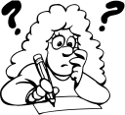

English working paper

Name:
.......................
Module: 1
Lesson: 1a
Classroom:
........................
Activity:
.......................

2- Is he happy? No, he ……..
1- ……..they Saudi? Yes, they are.
3- ……… you a teacher? No, ………. .
Complete:

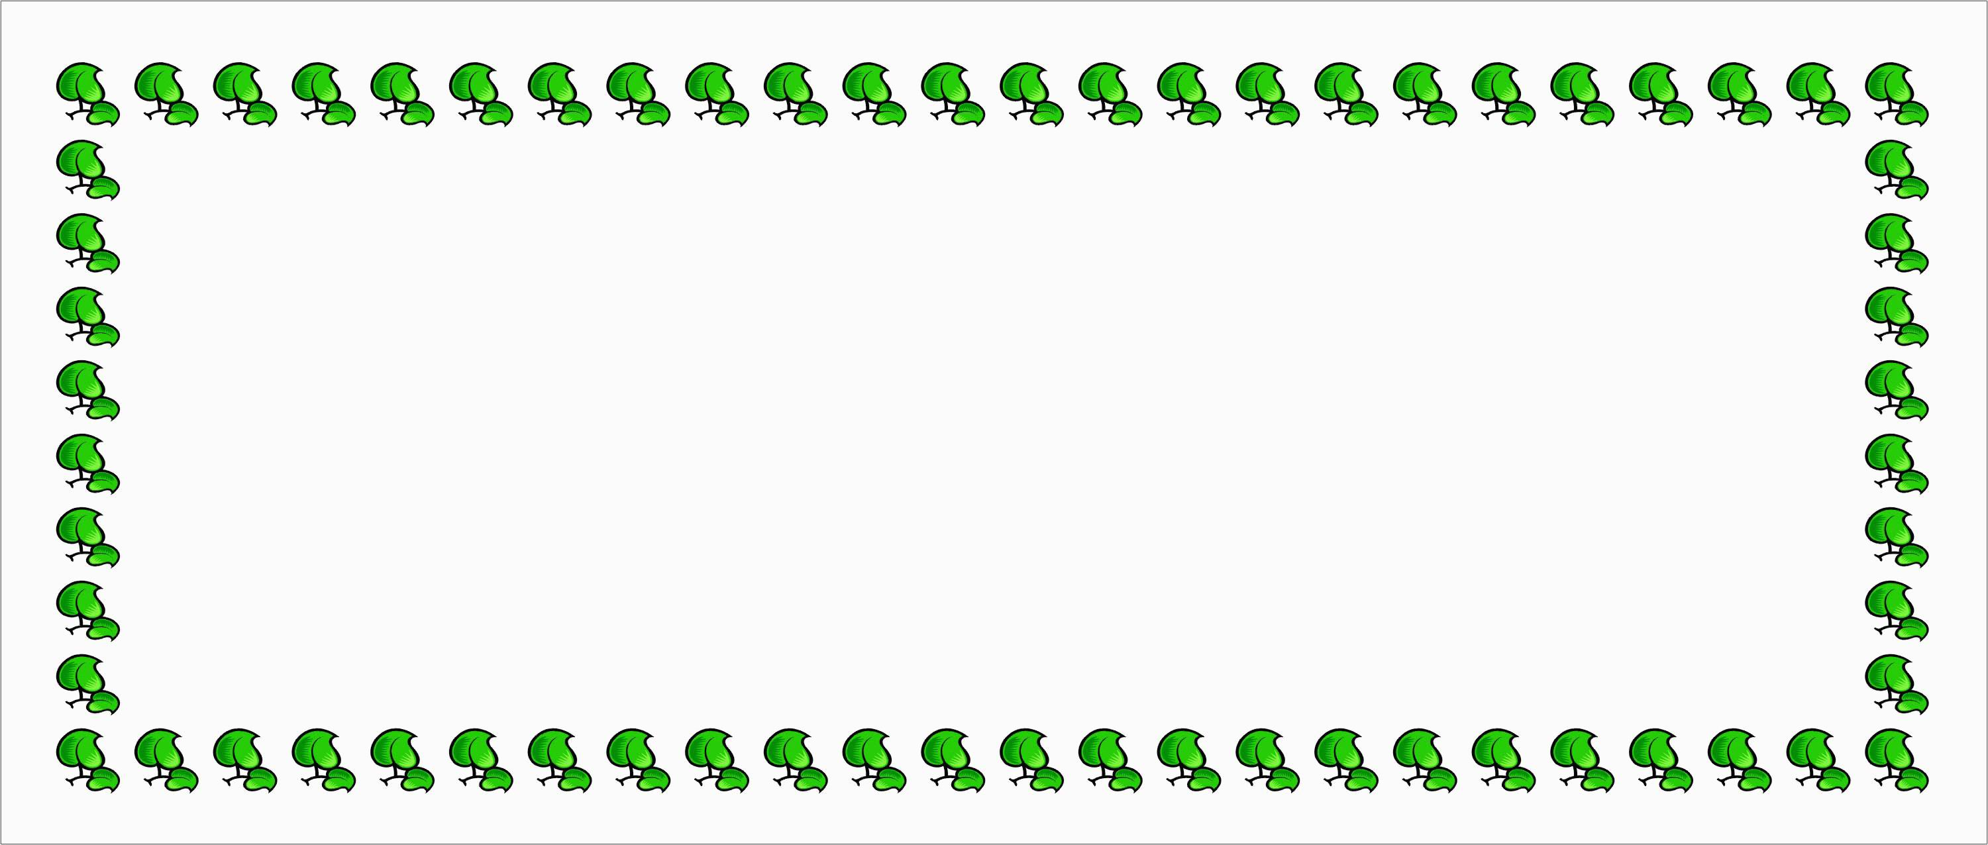
Complete the form then write a paragraph using it:

First name: ……………….

Surname: …………………

Address: …………………

Tel No: ………………….


Write the names of these things:


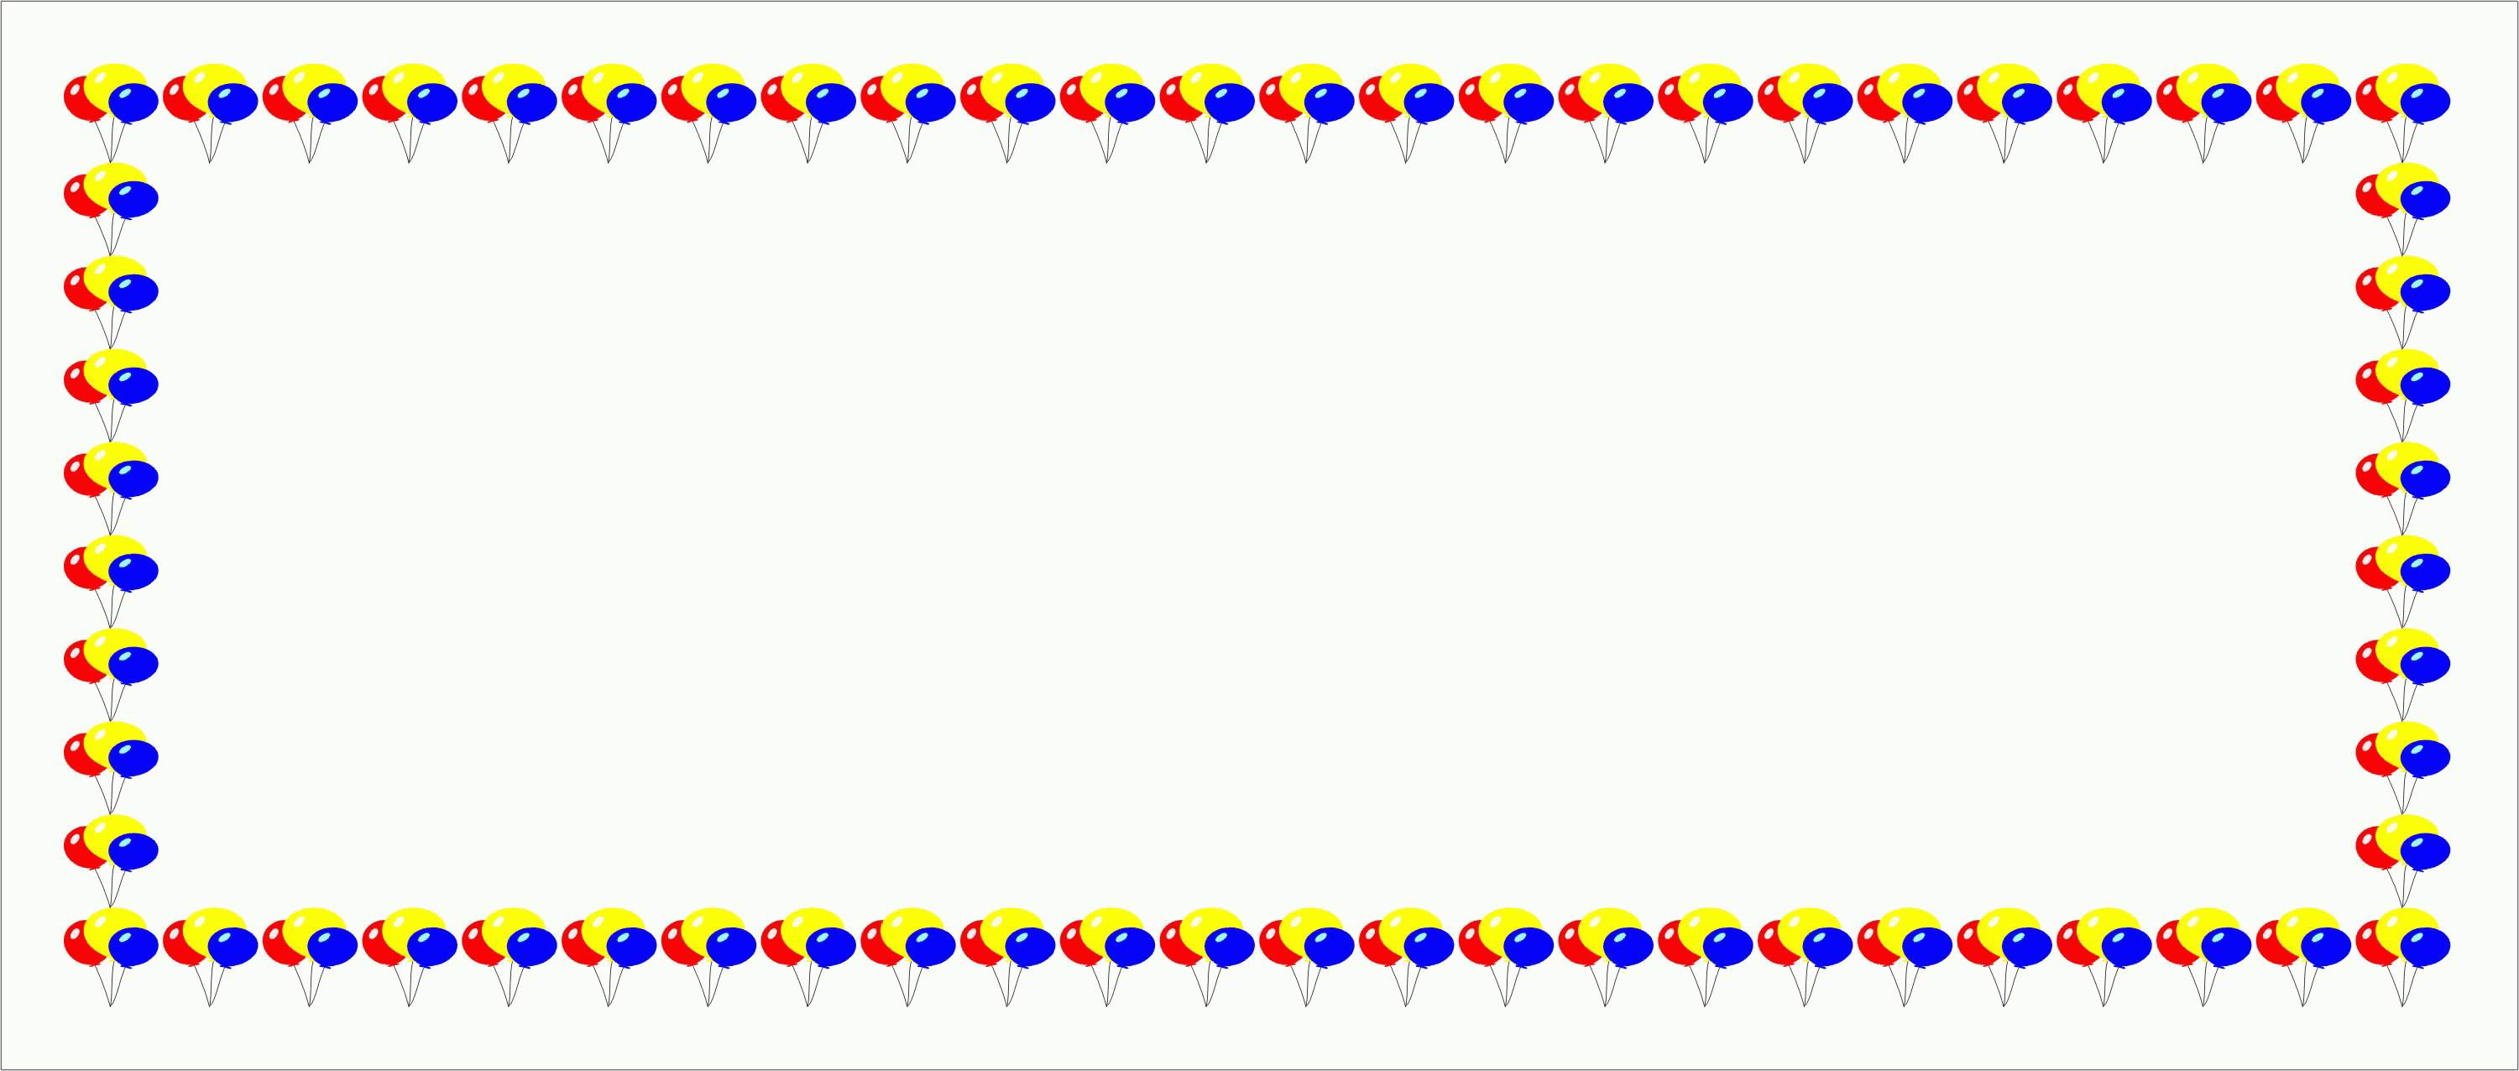
Circle the correct word:

- They have a blue car. (It’s – Their) car is expensive.
- (Those – These) are my books here.
- My ( parent’s – parents’ ) car is very big.
- Is that (Alis’ - Ali’s ) house?
- I like my sister. (His – Her) dress is beautiful.


English working paper

Name:
.......................
Module: 1
Lesson:1b
Classroom:
........................
Activity:
.......................


Complete with the verb can:
English working paper

Name:
.......................
Module: 1
Lesson:1c
Classroom:
........................
Activity:
.......................

- ……………….(they/ ride) a horse? No, ……….
- I …………….(speak) English, but I …………(speak) French.
- Ali ………..(use the computer). He is very clever.
- You …….. (drive) the car. You don’t have a car.
- You ……...(work) full time because you are very tired.
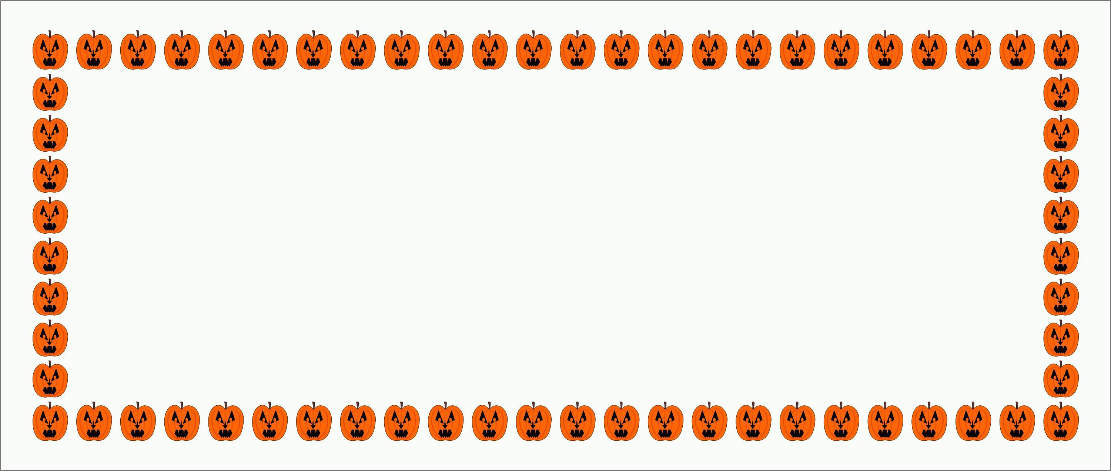
Match:


Architect
Photographer

1 2
3 4
What is the time?

- it’s ……….

- It’s ……….

- It’s ……….

- It’s ………
English working paper

Name:
.......................
Module: 1
Lesson:1d
Classroom:
........................
Activity:
.......................

Match the adjectives with pictures:

Hungry
Bored

Tired


Writing:

Use the table above to write a paragraph:
………………………………………………………………………………………………………………………………………………………………………………………………………………………………………………………………………………………………………..
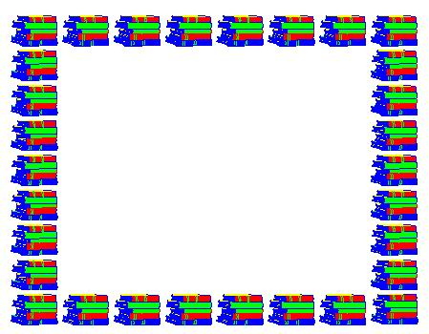
Complete the table:
Age: ………………

Hobby: …………….

Job: ………………...

Personality: ………….


English working paper

Name:
.......................
Unit: 1
Lesson:6
Classroom:
........................
Activity:
.......................
English working paper

Name:
.......................
Module: 1
Lesson:1e
Classroom:
........................
Activity:
.......................

Writing:

Write a paragraph about what you can do and what you cannot do.
___________________________________________________________________________________________________________________________________________________________________________________________________________________________________________________________________________________________________________________________________________________________

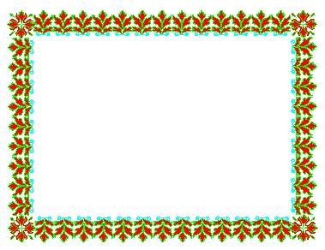
Circle the correct word:

- My (sister’s – sisters’) bag is red. It isn’t white.
- (Those – These) are my books over there.
- He can (ride – rode) the motorbike.
- She is (hungry- thirsty). She wants some water.
- They have a black dog. (Their – they) dog is interesting.
English working paper

Name:
.......................
Module: 1
Lesson: Round-up
Classroom:
........................
Activity:
.......................
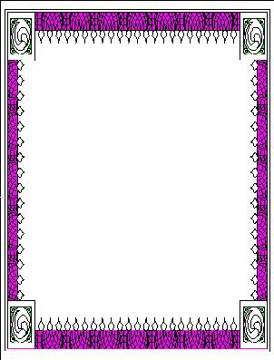
complete the blanks with present simple:

- she ……….(not play) basketball but she ……(play) tennis.
- I ………(get up) early every day.
- They ……….(not like) going to cinema.
- You ……….(work) hard every day.
- He……..(visit) his grandfather every Friday.

English working paper

Name:
.......................
Module: 2
Lesson:2a
Classroom:
........................
Activity:
.......................


Fill in the space with a preposition:

- She works ……. five to ten.
- They go to shopping …….the weekend.
- I don’t have breakfast……..Friday morning.
- I study hard …….. weekdays.



Complete with the present simple:

What .........you........(do) every morning?
.......he .......(speak) English?
Yes, he..........
.......they .......(play) well? No, they ........

Write the job:

............................

..........................

....................

English working paper

Name:
.......................
Module: 2
Lesson:2b
Classroom:
........................
Activity:
.......................
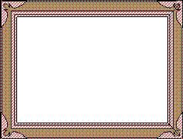
Complete:

- I would like ……(play)football.
- He enjoys ……..(hang up) with his friends.
- You can’t stand ………(eat) fish.
- I want …….(go) shopping.
- I hate …….(drink) coffee.

English working paper

Name:
.......................
Module: 2
Lesson:2c
Classroom:
........................
Activity:
.......................

Match:
- Hang shopping at the mall
- Watch a newspaper
- Read out with friends
- Go TV
- Talk on the phone
- Take up a sport



- Download the Net

- Check information

- Surf a message

- Send my e-mail
Match:


Use these adverbs to write sentences:
( always- usually – sometimes – rarely- often)
- ……………………………….
- ………………………………
- ………………………………
- ………………………………..
- ………………………………..

English working paper

Name:
.......................
Module: 2
Lesson:2d
Classroom:
........................
Activity:
.......................

Make sentences by putting the words in the correct order:
- surfs – he – every – the Net- day
_____________________________________________
- stand – can’t – I – drinking – coffee.
_______________________________________________
- Playing- I – tennis – hate
______________________________________________


English working paper

Name:
.......................
Module: 2
Lesson:2e
Classroom:
........................
Activity:
.......................

Write a short paragraph about
how you spend your free time.

Writing:

______________________________________________________________________________________________________________________________________________________________________________



Writing:

Write a paragraph about what your friend likes and dislikes.
___________________________________________________________________________________________________________________________________________________________________________________________________________________



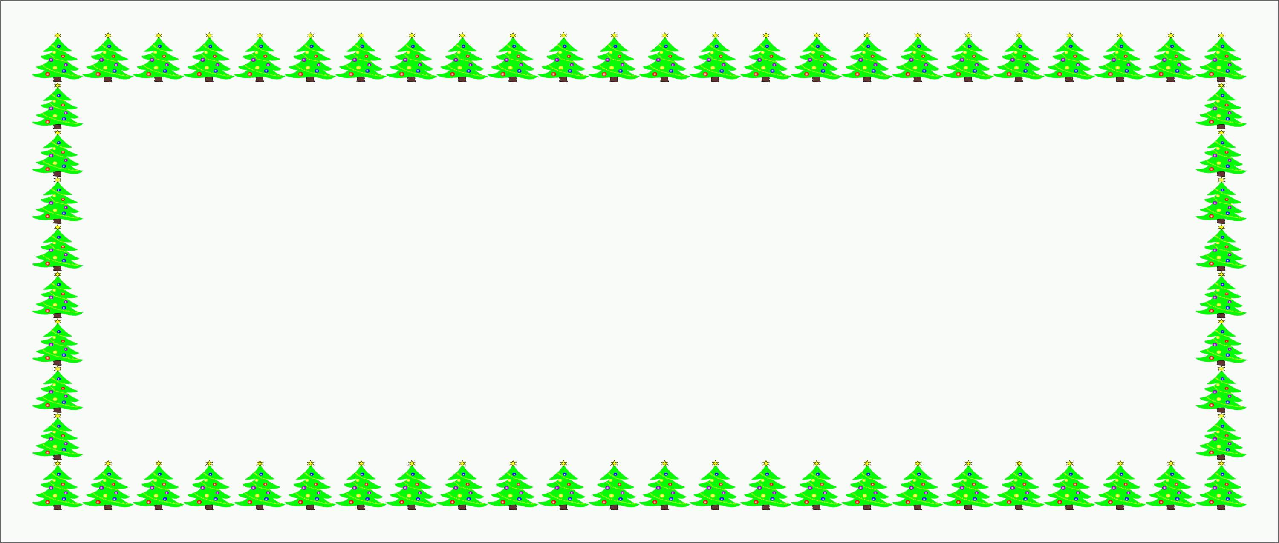
- He (work- works) every day (to- from) seven (to – at) two.
- (Do- Does) you (play – plays) tennis?
- He (watches – surfs) the net every Friday.
- The film starts (at –in) 7:00.
Choose the correct answer:



English working paper

Name:
.......................
Module: 2
Lesson: Round-Up
Classroom:
........................
Activity:
.......................

Complete with the present progressive:

- she ……..(draw) a picture at the moment.
- She ……..(getting) married next year.
- The children ……..(eat) lunch now.
- She ……..(look for) her books.
- They …….(come) tomorrow.
English working paper

Name:
.......................
Unit: 3
Lesson:4
Classroom:
........................
Activity:
.......................
English working paper

Name:
.......................
Module: 3
Lesson:3a
Classroom:
........................
Activity:
.......................

Writing:

Write an e-mail to your friend telling him/ her about your news.
____________________________________________________________________________________________________________________________________________________________________________________________________________________________________________________________________________________________________________________________________________________________________



English working paper

Name:
.......................
Module: 3
Lesson: 3b
Classroom:
........................
Activity:
.......................


Write the names of the items:

- -------------------
- -------------------
- -------------------
- -------------------
- -------------------
- -------------------

Circle the correct answer:

- (Whose – Who’s) books are these? They are (mine- my)
- (Whose – Who’s) that? He is (hers – her) husband.
- They have a dog. (Their – they) dog is clever.
- Is this Ali’s pen? Yes, it is (his- he’s)
- It is (my – mine) dress.

English working paper

Name:
.......................
Module: 3
Lesson:3c
Classroom:
........................
Activity:
.......................


Complete the spelling.

Lib---y
Sta--um
Undergr--nd
b--kshop





Circle the correct answer:

- (There’s – Is there) a museum near your house?

- There (is – are) two boys playing in the street.

- (There are – Are there) clothes here? No, there (isn’t – aren’t )

- There (is – are) (a –an) underground station here.

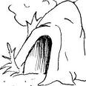

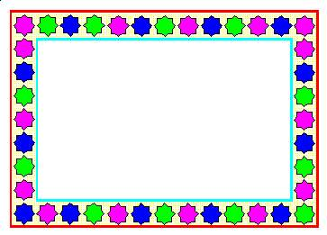
What is the weather like?

…………………… ………………………
…………………………………



Choose:

- Look, it’s (rain – raining).
- They (go – are going) to school everyday.
- She (is getting – gets) married next year.
- Now, she (is watching – watch ) TV.
- I (go – am going) to the cinema every Friday.
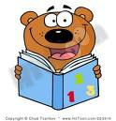
English working paper

Name:
.......................
Module: 3
Lesson:3d
Classroom:
........................
Activity:
.......................

Write an e-mail to your friend telling him/ her about your neighbourhood and your house.

______________________________________________________________________________________________________________________________________________________________________________________________________________________________________________________________________________________________________________________________________________________________________________________________________________________________________________________


English working paper

Name:
.......................
Module: 3
Lesson:3e
Classroom:
........................
Activity:
.......................

Write the names of the items:

- ------------------------------------
- ------------------------------------
- ------------------------------------
- ------------------------------------
- ------------------------------------

Circle the correct word:

- This house isn’t (our – ours).

- I love Egypt, (special – especially ) in Summer.

- (Who’s – Whose) book is that? It is (my –mine)

- She (is cooking – cooks) lunch now.

- He (is playing – plays) football everyday.



English working paper

Name:
.......................
Module: 3
Lesson: Round-up
Classroom:
........................
Activity:
.......................

Match:

- Bus room
- Air machine
- Besides station
- Washing conditioner
- Bed table

English working paper

Name:
.......................
Module: 4
Lesson:4a
Classroom:
........................
Activity:
.......................

Match:

A bottle of coke
A can of pizza
A slice of milk
A glass of tea
A cup of soup
A bowl of water

Complete with (Some - any - no)

- There is ……. fruits in the fridge.

- There aren’t …….. milk in the fridge.

- There is ……cheese in the sandwiches but there is ……. jam.

- Is there ……..coke there?

- Would you like……tea?


Complete the spelling.

Auber---es
Let--ce
Cher---s
Pl-ms
p--hes


Choose the correct word:

- How (much – many) hours do you study?

- Would you like (a few- a little) peas in your salad?

- How (much – many) money does it cost?

- We usually eat (a lot of – much ) apples.

- We don’t have (much – many) time.

English working paper

Name:
.......................
Module: 4
Lesson:4b
Classroom:
........................
Activity:
.......................
English working paper

Name:
.......................
Module: 4
Lesson:4c
Classroom:
........................
Activity:
.......................


Complete:

The prophet Mohammed (P.B.U.H.) said, "I and the ------------ of the orphan will be in -------------- like that" indicating his
---------------- and middle finger.



Fill in the space
1- My room is untidy. I want to arrange ……..
2- This is your brother. I don’t like………
3- We will go to cinema. You can come with …..


Write using (should - should not)

- He plays football. He hurts his arm.
______________________________________________

- She wants to go out but she is tired.
______________________________________________

- She is very fat. She doesn’t go to the gym.
______________________________________________

Complete:

- My head hurts. I have ………..

- My throat hurts. I have……….

- My back hurts. I have……….

- My stomach hurts. I have ……..

English working paper

Name:
.......................
Module: 4
Lesson:4d
Classroom:
........................
Activity:
.......................


Writing:

Write a paragraph to your friend who is sick giving him/ her some advices.
____________________________________________________________________________________________________________________________________________________________________________________________________________________________________________________________________________________________________________________________________
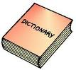

Write the meaning:

- work out --------------------------------------------------------
- do aerobics -----------------------------------------------------
- join the gym ----------------------------------------------------
- fit -----------------------------------------------------------------

English working paper

Name:
.......................
Module: 4
Lesson:4e
Classroom:
........................
Activity:
.......................
English working paper

Name:
.......................
Module: 4
Lesson: Round-up
Classroom:
........................
Activity:
.......................
English working paper

Name:
.......................
Unit: 3
Lesson:6
Classroom:
........................
Activity:
.......................


________________________________________________________________________________________________________________________________________________________________________________________________________________________________________________________________________________________________________________________________________________________________________________________________________________________________________________________________________________
Write an e-mail to your friend asking him / her for advice as you want to be fit.


Choose the correct word:

- Do you want (some – any) orange juice?
- I like apple (but/ and) I don’t like apple juice.
- She is fit (but- because) she goes to the gym.
- Give me ( a bowl – a bottle) of soup.
- Would you like ( much – many) water?
- You (should – shouldn’t ) go to the gym to be fit.

Fill in the space.

Fly
Land
Eat
Study
................

................
................

................



Correct the words in the brackets.

1- I ---------------- (go) to the cinema last Friday.
2- My mother --------------- (visit) her friend yesterday.
3- They ------------------ (travel) to Paris last year.
4- she ------------------- (come) to my house two days ago.



Write the past simple form.
English working paper

Name:
.......................
Module: 5
Lesson: 5a
Classroom:
........................
Activity:
.......................

Complete the sentences with past simple:

- Who …………(you/ see) yesterday?
- When ……..(she/come) to the party?
- ………you ……(see) my mother yesterday? No, I …….
- ………she …….(visit) Egypt last year? Yes, she ……..
- What ………..(you/ do) last night?

Complete the spelling.

Chem---ry
Ph---cs
Geog---hy
His---y
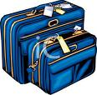
English working paper

Name:
.......................
Module: 5
Lesson: 5b
Classroom:
........................
Activity:
.......................
Fill in the space.

1- Where…….you yesterday? I ……at the supermarket.

2- ……… there many people in the party yesterday?

3- She ………at the museum last Friday.


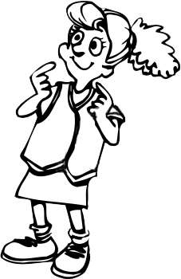
Fill in the space....

Sig--seeing
Cam--ng
winds---ing
hik---
English working paper

Name:
.......................
Module: 5
Lesson: 5c
Classroom:
........................
Activity:
.......................

English working paper

Name:
.......................
Module:5
Lesson:5d
Classroom:
........................
Activity:
.......................

Complete with the verb could or can:

- ……..you …….(write) at the age of 4? No, I ………
- ……..you …….(speak) English? Yes, I …….
- She ……..come yesterday because she was ill.
- He ……..walk when he was at the age of 5.

Write

Write a short biography about a person you admire.

___________________________________________________________________________________________________________________________________________________________________________________________________________________________________________________________________________________________________________________________________________________________________________________________________________________________________________________________________________________________________________________________________________________________________________________________________________________________________________________________________________________________________________________________________________________________________________________________________________________________________________________________________________________________________________________________________________________________________________________________________________________________________________________________________________

English working paper

Name:
.......................
Module: 5
Lesson: 5e
Classroom:
........................
Activity:
.......................

I was shocked when I saw the murder, but -----------he didn’t see me.
Yesterday, I decided to go out, but ----------------it was raining.
I was running but -------------------------- I fall down.
Complete with suitable adverbs:

Write the meanings in Arabic:

Burglary -----------------------------------------

Security guard ----------------------------------

Get away -----------------------------------------

Shout ---------------------------------------------

Write an e-mail to your friend telling him/ her about a day you spent with your cousins.
_____________________________________________________________________________________________________________________________________________________________________________________________________________________________________________________________________________________________________________________________________________________________________________

Writing:
Choose the correct word:

- What course did you (take – took) at the college?
- She (could – couldn’t ) speak at the age of 1.
- (suddenly – luckily) when I was working, the machine stopped.
- She speaks English (good – well)
- I can (easy – easily) pass the exam.
English working paper

Name:
.......................
Module: 5
Lesson: Round-up
Classroom:
........................
Activity:
.......................
Complete with the future going to:
English working paper

Name:
.......................
Module: 6
Lesson:6a
Classroom:
........................
Activity:
.......................

- What ----------------------------------------- (time/you/ visit) Dubai this holiday?
- She -------------------------------- (travel) next summer.
- They ------------------------------- (buy) a new car next month.
- I ---------------------------- (visit ) my uncle in Paris next month.
- The party ------------------------- (take place ) in the park next week.

Writing:

Write an e-mail to your friend talking about the Teacher,s Day event you are going to attend and telling him about the activities.
___________________________________________________________________________________________________________________________________________________________________________________________________________________________________________________________________________________________________________________________________________________________________________________________________________________________________________________________________________

- He ……..his trip yesterday because he was tired.
- I ……some books from my friend.
- I ….. clothes to my sister.

Complete

lend

borrow

cancel
English working paper

Name:
.......................
Module: 6
Lesson:6b
Classroom:
........................
Activity:
.......................

Write a request and answer with refusing:
- A: borrow / books?
B: sorry/ read.
____________________________________________________________________________________________________________

- A: go/ shopping/ with me?
B: sorry/ tired.
____________________________________________________________________________________________________________

- A: lend/ your dress?
B: afraid/ wear/ at the party.
____________________________________________________________________________________________________________
Correct the following sentences:
- How about go to cinema?
__________________________________________________
- Let’s playing football.
__________________________________________________
- Why don’t we visiting your grandmother?
__________________________________________________
Match:

Bear shark chicken elephant
English working paper

Name:
.......................
Unit: 1
Lesson:6
Classroom:
........................
Activity:
.......................
English working paper

Name:
.......................
Module: 6
Lesson:6c
Classroom:
........................
Activity:
.......................
Choose the correct word:

- I saw (somebody – nobody) walking in the park.
- Let’s go (somewhere- any where) together.
- I have (anything – nothing) to give to you.
- I know (everyone- someone) in the party. They are all my friends.
- He didn’t win (anything – something).

Write the meanings in Arabic.

Festival ------------------------------------
Sacrifice -----------------------------------
Prayer -------------------------------------
Religious ----------------------------------
Celebrate ---------------------------------
Generosity --------------------------------
English working paper

Name:
.......................
Module: 6
Lesson: 6d
Classroom:
........................
Activity:
.......................
Match:

Happy Eid Get well soon. Congratulation
English working paper

Name:
.......................
Module: 6
Lesson:6e
Classroom:
........................
Activity:
.......................

Write an e-mail to your friend inviting him/ her to your party after graduation
_____________________________________________________________________________________________________________________________________________________________________________________________________________________________________________________________________________________________

Complete :

There isn’t ---------------------- (any)in the house.
I ------------------------------ (visit) my friend tomorrow.
She ----------- (has to/have to) study for the exam.
Write:

1-………..

2-………..

3-……….

1-………..

2-……….

3-………..
1-………….

2-………….

3-…………

Three months

Three ordinals

Three animals

English working paper

Name:
.......................
Module: 6
Lesson: Round-up
Classroom:
........................
Activity:
.......................
Choose the correct word:

- I want to buy a bag. Let’s see the red (one- ones)
- She wants to give me these gloves but I want the red (one – ones)
- I don’t have (enough – too) money to buy clothes.
- This is (too – enough) heavy. I can not carry it.
- It isn’t big (too – enough) I want another one.

English working paper

Name:
.......................
Module: 7
Lesson:7a
Classroom:
........................
Activity:
.......................

Write names of the things:

………… ……………. …………… ……………… ………………

Write few sentences to compare two of your friends.

……………………………………………………………………………………………………………………………………………………………………………………………………………………………………………………………………………………………………………………………………………………………………………….
Writing:

Complete:

- Ahmed is -------------- (tall) than Omar.
- Hana is ------------------------- (handsome) than her sister.
- She is ---------------- (good) than her friend.
- The museum is --------------------- (far) than the park.
- This exam is -------------- (bad) than the previous one.

English working paper

Name:
.......................
Module: 7
Lesson:7b
Classroom:
........................
Activity:
.......................
Write the names of these means of transport:

…………. ………….. ……… ………….

English working paper

Name:
.......................
Module: 7
Lesson:7c
Classroom:
........................
Activity:
.......................

Complete the table with the correct form of the adjectives
Adjectives | Comparative  Form | Superlative  Form
warm | warmer
rude | ruder | rudest
 |  | the laziest
big
different |  | the most different
 |  | the best
bad |  | the worst
much/manv
 | farther/further

Write a paragraph describing to your friend how to go
to a place near your house.
___________________________________________________________________________________________________________________________________________________________________________________________________________________________________________________________________________________

through
out of
around
Match:

English working paper

Name:
.......................
Module: 7
Lesson: 7d
Classroom:
........................
Activity:
.......................
English working paper

Name:
.......................
Unit: 3
Lesson:4
Classroom:
........................
Activity:
.......................
English working paper

Name:
.......................
Module: 7
Lesson:7e
Classroom:
........................
Activity:
.......................

Writing:

Write a paragraph about a person you admire.
______________________________________________________________________________________________________________________________________________________________________________________________________________________________________________________________________________________________________________________________________________________________________________________________________________________________________________________________________________________________________________________________________________________________________________________________________________________

English working paper

Name:
.......................
Module: 7
Lesson: Round-up
Classroom:
........................
Activity:
.......................

Writing:

Choose two of your friends and write a paragraph comparing them.
_____________________________________________________________________________________________________________________________________________________________________________________________________________________________________________________________________________________________

Choose the correct answer:

- Go (through – past) the park and the post office is on your left.
- It is (too – enough) expensive. I can not buy it.
- I can (pay – get) in cash.
- I have a lot of dresses but the red (one – ones) is wonderful.
- I want to buy earrings. I choose the silver (one- ones)

English working paper

Name:
.......................
Module: 8
Lesson:8a
Classroom:
........................
Activity:
.......................

Complete the spelling.

Vol--no
Water---l
De--rt
Mount--n

Complete with present perfect:

- I --------------------------- (not travel ) by plane.
- ----------------------------- (he/ ride) a horse before?
- He -------------------------- (never/ have) an accident.
- You ------------------------ (spend) the summer holiday in mountains.
- ------------ you ---------------------- (ever/ try) windsurfing?

Choose the correct word:

- I (lost – have lost)my wallet yesterday.
- I (travel – have traveled) twice a year.
- She (visited- has visited)Egypt last year.
- She (has broken – broke) her leg.
- They (went – have gone) shopping last week.

Complete with these words:

(break down – out of order- lost – run out of)
- I have ------------------------------- petrol.
- My car has --------------------and I cannot fix it.
- I have ----------------------- my bag.
- The lift is -------------------- and I am stuck in it.
English working paper

Name:
.......................
Module: 8
Lesson:8b
Classroom:
........................
Activity:
.......................
report these sentences:

- “Use your dictionary, Ali,” said the teacher.
________________________________________________
- “Please pay attention, Rida,” said the instructor.
________________________________________________

English working paper

Name:
.......................
Module: 8
Lesson:8c
Classroom:
........................
Activity:
.......................

Write the names of the items:

………… ………… ……….. ……….. ……
Writing:

Use the information above to write a paragraph
about the country you have chosen.
______________________________________________________________________________________________________________________________________________________________________________________________________________________________________________________________________________________________________________________________________________________________________________________________________________________________________________
English working paper

Name:
.......................
Module: 8
Lesson: 8d
Classroom:
........................
Activity:
.......................

Choose a country and fill the table about it:

Location:
Capital:
Population:
Official language:
Highest mountain:
Largest lake:

English working paper

Name:
.......................
Module: 8
Lesson:8e
Classroom:
........................
Activity:
.......................

Match:

Hang-gliding waterskiing rock climbing white-water rafting

Replace the underlined words:

- My sister and I went shopping yesterday. My
sister and I (-----------) bought wonderful things.

- This is a wonderful park. We come to the park (-----------) every Friday.

- I usually go to the shopping centre. I go to the
Shopping centre (-----------) to buy new clothes.

Choose the correct word:

- They (traveled- have traveled) twice a year.
- These clothes aren’t (useful – suitable) to the children.
- I (have visited- visited) my uncle yesterday.
- He (has gone- has been ) to the supermarket and still there.
- This car has broken (up – down) . It can not work.

English working paper

Name:
.......................
Module: 8
Lesson: Round-up
Classroom:
........................
Activity:
.......................

Complete:
(of- out of – to – down)
- We run ------------------ milk yesterday.
- According ----------- the dictionary, port means left in sailing.
- My car broke ------------- and I couldn’t fix it.
- The lift is out -------------- order. We can not use it.

