
Quiz Unit ( 4 )
My Name ……………………………………………………………………………… Date : ………………/………/1435 .

* Vocabulary :
Q 1: Write the correctword under each picture :
( entrance - crazy mirror - competition - the winner - Chinese - rollercoaster - prize - amusement park )
4

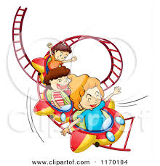





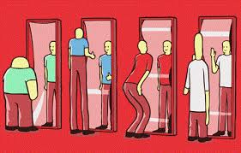
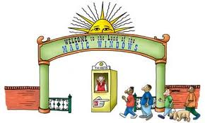
……..… …….…… …………… …….….

…………. …….….… ….…. …..… …….…..
* Grammar :
Q2 : Choose :
1- ( What – where ) is your father's name ?
6
2- ( Who – When ) do you go to school every day ?
3- She can ( speak – speaking ) Chinese .
4- Zainab is good at ( cook – cooking ) pictures .
5- Sara ( can't – not can ) speak English .
6- He likes (watch - watching ) T.V .
7- Can Noor read the word ?
( a ) No, we can . ( b ) No , she can .
8- Do you like watching DVD ?
( a ) Yes, I do . ( b ) Yes , I am .
9- Are you good at bowling ?

( a ) Yes, I do . ( b ) Yes , I am .

Mrs: Lamia
10

