إختبارالفتره الثانية : إنجليزي ثاني لعام 1432 الاسم : .................................................................. الصف 2 / .......
Comprehension:

Read the passage and answer the questions below:
This Red Sea port called the bride of the Red Sea. It is located on the western coast of the kingdom of Saudi Arabia. The area of the city is about 1,200 square km and the population is more than two million. Jeddah is famous for its huge fountain which rises about 200 meters from the sea.
C- Answer:

10

1
4
* What is Jeddah famous for ?
- It is famous for its ………………………………………………………………………………………………………………………………

B. Put ( √ ) or ( X ) for each sentence
* The city is located on the western of Kingdom . ( )
* The area of the city is about 3,100 square km ( )
C- Choose:
* The word ( It ) refers to.............................................
1- population. 2- Red Sea port. 3- Abha .
Information Questions
Choose:
1- place where you can buy medicine " a Vase - Prescription - Pharmacy "
2- something you put flower in it " a Vase - Prescription - Pharmacy "
Grammar
A-Choose:
1– Reading is ( more – good – as ) useful than watching T. V
2-Where (was – is – were) they last week ?
B - Do as shown in brackets
1-Were the boys in the class yesterday? Yes, ……………………………… { Complete the answer }
2- She / study hard. ……………………………………………………………….……. { use should }.
- Ali is ( good ) than Sami ………………………….. { correct the adjective }
________________________________________________________
Vocabulary
A-Circle the odd adjective :
- City : Hot - crowded - happy - quiet
- Mountain : high - noisy - green - big

B-Write the words under each picture:
Swollen ankle - Dizzy - Chicken box - Cough - Food posioning

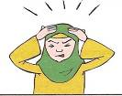
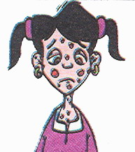
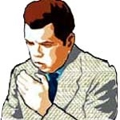

_____________ ______________ _______________ ___________
Spelling
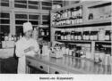
A -Choose the right words
1 - dicpenkiry - decibnasry - dispensary
2 - fonfker - funfair - famfeir

Hand writing

A - Copy the following sentences :
They go to Britain by airplane

Good Luck, Your Teacher :

