Write the correct word under each picture :
( rout-battery -hill - backpack -boots - torch )

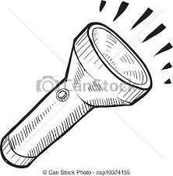
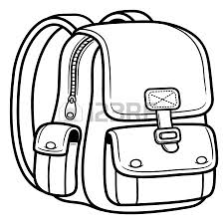
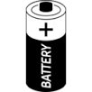
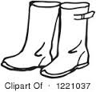


…………………… ……………………… …………………… …..………..…… ………………… …………………

Complete :
( water proof -invitation -half term- forecast)
1-You have to check the weather …………………………………… before trip .
2- I'll travel to Dubai at the ………………………………….. holiday .
3- please accept my …………………………………… to the party .
4- My watch is ………………………………………………………

E.T :Lamia Al-Fadil

