Name: .............................................................
Class: 1 / ..............

.

Complete :
1- What ................... you ................?
3- Would you like ............................?
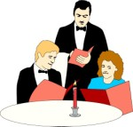

4- ............, please. ............
................... orange juice.
2- ......................... soup and pizza, ......................

~~~~~~~~~~~~~~~~~~~~~~~~~~~~~~~~~~~~~~~~~~~~~~~~~~~~~~~~~~~~~~~~~~~~~~~

A- Choose:
- [ Do - Does - Doing ] you study English?
- Yes, I [ do - does - don't ].
- [ Do - Does - Doing ] he like the food?
- No, he [ does - do - doesn't ].
- [ Why - What - When ] is the shopping mall open?
- I don't want to buy it. It's [ expensive - very expensive - very cheap ].
- Omar [ was - were - am ] asleep on the bus.
- They [ was - were - is ] in the park.


B- Write. Use : Let's.
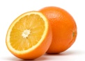
1- (eat ) ................................................. 2- ( watch ) ...................................................

C- Match each question to its answer:
- What's the time? ............... It's red.
- How much is the TV? ............... We're going on Friday.
- Why are you late? ............... It's five o'clock.
- Do you like tea? ............... It's 9000 SR.
- What colour is the bike? .............. Because my watch was wrong.
- When are you going to the zoo? .............. Yes, I do. I love it.

-1-

D- Complete:
1) Do they like the food? I'm sorry, ...........................

2) ........................ write Arabic? I'm sorry, he can't.
3) What can you see? ................................................
4) What ................................................? I can smell flowers.

E- Write correctly:
- late / sorry / im / im ....................................................................
- too / its / expensive ...................................................................
- go / the park / lets / to ...................................................................
- old / very / hes ...................................................................

~~~~~~~~~~~~~~~~~~~~~~~~~~~~~~~~~~~~~~~~~~~~~~~~~~~~~~~~~~~~~~~~~~~~~~~~~

300
Five thousand
6,000,000
Thirty thousand

A-Write the numbers:

B- Write the opposites:
- It's fat . It's .......................
- The door is closed. The door is ............................
- My hair's long. Her hair's ..............................
- He's scruffy. He's .....................................
peppers
garlic
potatoes
tomatoes
olives
onions
river
Pyramids
angry
hospital

C- Match the words with the pictures:
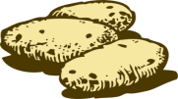 | 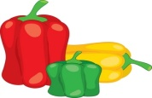 | 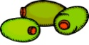 | 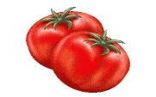 | 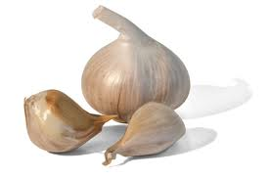
1- | 2- | 3- | 4 | 5-
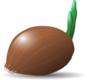 |  |  |  | 
6- | 7- | 8- | 9- | 10-

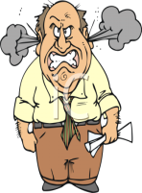

Write the words correctly:

1) clirag ......................... 2) grany .............................. 3) vierr ............................

4) msrat ........................ 5) tale ............................... 6) mootat ............................

-2-

