Name: .............................................................
Class: .........................

time / Would / Yes / I'd love to
1- Choose and complete the dialogue:

1- ............................ you like to come
shopping with me on Thursday?


2- Yes, ..................................

3- What ...................... would you
like to meet ?

what

4- Is 4 o'clock OK ?
5- ..................,
That's fine.

2- Write the conversation in order:
Have some bread and cheese.
I'm hungry.
Thank you.
What's the matter?
...................................................................................................................
....................................................................................................................
....................................................................................................................
....................................................................................................................

~~~~~~~~~~~~~~~~~~~~~~~~~~~~~~~~~~~~~~~~~~~~~~~~~~~~~~~~~~~~~~~~~~~~~~~~~~~~~~~~~~~~~~~~~~~

1- Choose :
- [ Do - Can - Would ] you like to come to my house?
- Yes, [ I like - I'd love to - I love to ].
- [ Am - Is - Are ] they watching T.V ?
- No, they [ are - aren't - is ].
- [ What - Where - When ] is it called in English?
- [ He's - It's - They're ] called a car.
- I always [ help - helps - helping ] my mother.
- She sometimes [ drink - drinks - drinking ] tea in the morning.
- Omar usually [ is - has - have ] lunch at 2 o'clock.
- What [ does - doing - do ] you do on Thursday?

2- Write. Add - ing :
cook .................... write ....................... eat ..................... take ........................

-1-

3- Write correctly :
- good - oranges - smell ........................................................................
- are - you - what - cooking ........................................................................
- like - don't - i - cheese ........................................................................
- love - i - kapsa ........................................................................

~~~~~~~~~~~~~~~~~~~~~~~~~~~~~~~~~~~~~~~~~~~~~~~~~~~~~~~~~~~~~~~~~~~~~~~~~~~~~~~~~~~~~~~~~~~~
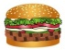



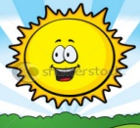
1- Choose :
- It [ smells - tastes - looks ] good.
- He's [ thirsty - hungry - tired ].
- It's [ raining - sunny - windy ] today.
- I usually have [ breakfast - lunch - dinner ] in the morning.
- Makkah's in the [ east - north - west ] of Saudi Arabia.
- [ Riyadh - Abha - Jeddah ] is in the centre of Saudi Arabia.

2- Choose the odd word:
Riyadh
north
south
west
tired
sunny
thirsty
hungry
plate
fork
spoon
rice
windy
snowing
raining
east
look
taste
food
smell
a. b. c. d. e.

3- Write the opposites :
wet
never
hot
small
new

- It's cold today. It's ..................... today.
- He's got a big bike. He's got a ........................... bike.
- It's dry today. It's ....................... today.
- She's got an old book. She's got a ....................... book.
- They always watch T.V. They ....................... watch T.V.

4- Write the correct word under each picture :

windy - plate - chicken - spoon - bread - rice - fork - knife - tea - raining

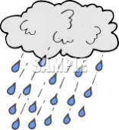
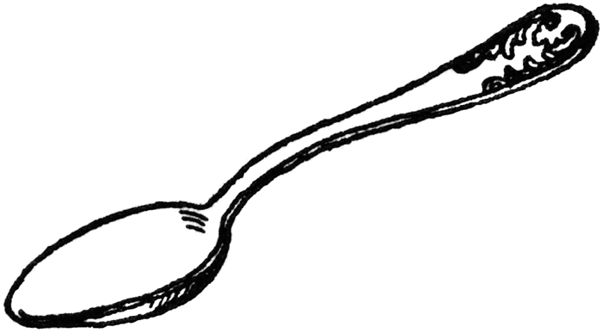
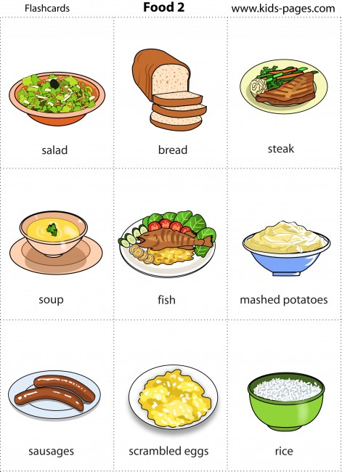
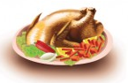
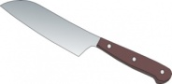

a) ................................ b) ............................. c) ............................. d) ............................. e) ...........................

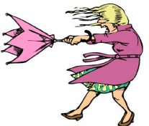
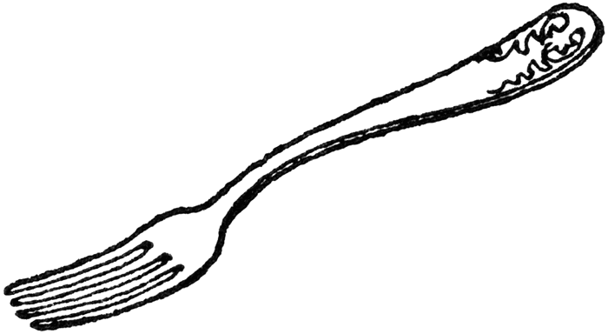



f) ............................ g) .............................. h) ........................... i) ................................. j) ..............................

-2-

