Quiz unit Trends 1
Name: class:
Answer the followings:
1-Compare between rural life and urban life ?(mention 2 for each)
………………………………………………………………………………………………………………………………………………………………………………………………………………………………………………………………………………………….
2-Grammar: Do as required in brackets:
1-There is (much ) food in the fridge .(Correct)
………………………………………………………………………………………………..
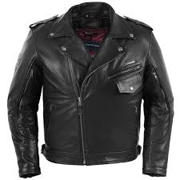
2-Did you get (all-both-neither) the things from the market that were on your list?(choose)
3-It is a ………………………………………………………………………. (Complete)
4-In this game , you (either –neither – both ) win or lose. It depends on you
_________________________________________________________________________


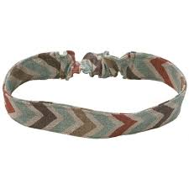

3-Vocab: A-Write the correct word for each picture:

B-Match :
Restaurants , coffee shops | roads
gold | cufflinks
Skyscrapers ,block of flats | Eating places
metal | ring
 | buildings
**Helping question: Do as required :
1…………….. of my parents are Saudi Arabia . (Complete with the right quantifier )-
2- scarves are made of …………………………. (complete with right material)

