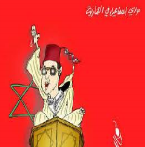
Unit (4 ) Lesson ( 3 )
My Name …………………………………………………………………………………………………………………………………………..

Q 1: Match the word with picture :

( Sultan - temperature - surgery - medicine- internet)
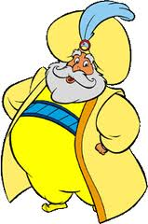
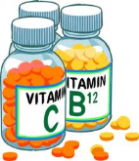

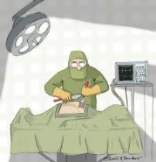
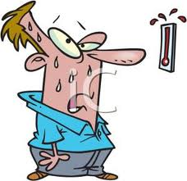

………… ………. ……… ….…… …………

Q 2: Choose and complete :
Degrees ) ( programme - die – internet – countries – Moroccan -
1-My temperature is 38 ………………
2-He comes from Morocco . He is ………………………..
3- Kuwait , Qatar ,Bahrain are ……………………………
4- I need …………………….. to send an e-mail .
5-He born in Makkah and ……………….. in Maddinah .
6- I watched a TV ………………………… in channel 2 .

Q3: Choose :
1- She ( start – started ) her talk an hour ago .
2- They ( like – liked ) to travel yesterday .
3- Fred is ( tall – taller ) than Jack .
4-My bag is ( colourfuler – more colourful) hers .



Mrs: Lamia

