Write the correct word under each picture :
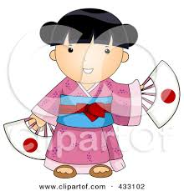
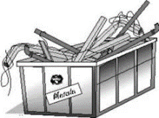
( chest / Japanese/ wooden/necklace /metal / silver / sword / teapot )
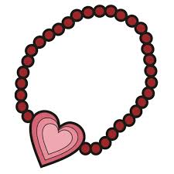
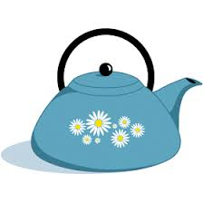
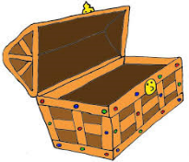
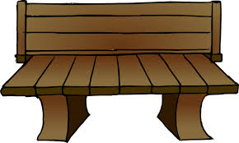
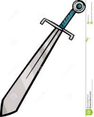

…………………… ……………………… …………………… …..………..…… ………………… …………………

Give the opposite :
Gold # ………………………………..

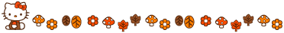

Complete :
( silver / English / beautiful )

1-It’s……………………………….. necklace . It's made of ………………………….. and It's

Choose :
1- My dress comes from ( Italy – Italian ) . It's ( Italy – Italian ) .

E.T :Lamia Al-Fadil

