

اختبار الفترة الأولى انجليزي الثالث المتوسط الفصل الأول

Choose the correct answer : - 1 -
1 – I'm very thirsty I ( would like to – like ) drink something

2 – Tea or juice ? I ( would like – like ) have tea please

2 – Do as shown between brackets :
1 – The country has changed
( make it negative )
……………………………………………………………………………………………
2 - I have broken my arm ?
( short it and make it question )
……………………………………………………………………………………………

3 - learn in formation study peoples grammer :
( join by using by )
……………………………………………………………………………………………..

- Match:

-teacher

- Doctor
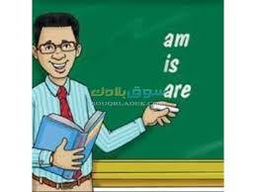
- editor

