

Unit ( 3 ) Lesson ( 3 )
My Name …………………………………………………………………………………………………………………………………………..

Q 1: Complete with the correct word :

Nervous – warm – talk – surprise ))
1-I have a ………..…………. For you , your mother's coming tomorrow .
2- Nina has a ………………. About Saudi Arabia next Thursday .
3- It's not cold or hot ,It's ……………. .
4- He's very …………… . , He has a meeting .

Q2: Choose :
1- I don't have ( some – any ) book .
2- Give me ( some – any ) apples , please ?
3- Fred hasn't got ( some – any ) Arabic lessons .
4- Nina and Elena have got ( some – any ) photographs togather .

I like ice cream very much .
So am I .

I'm very happy today .
So do I .

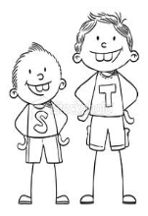
Mrs: Lamia

