Name _______________________________________ class 3\_______________
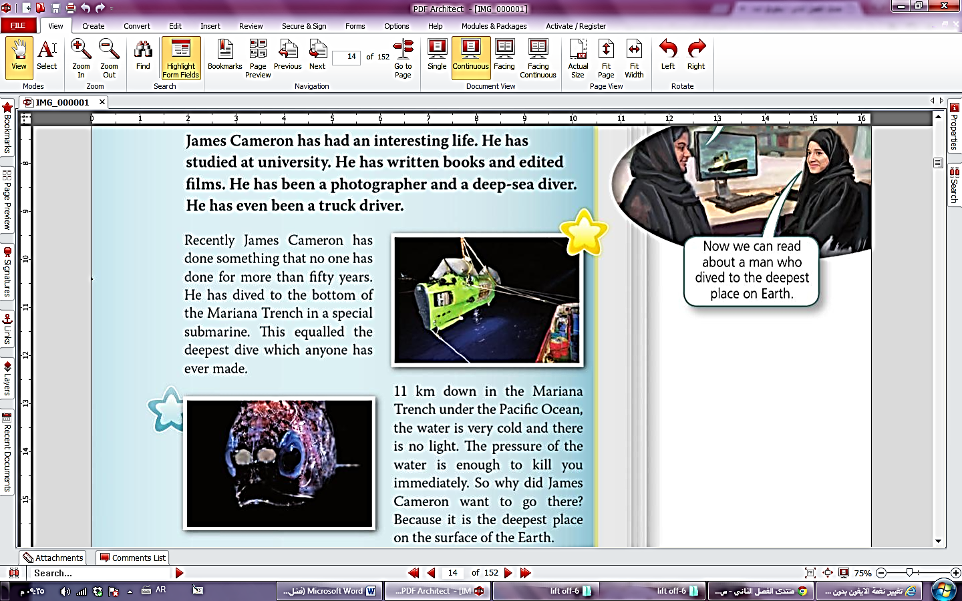
Read this passage then answer the questions below :

Answer these questions :
- Where has James Cameron studied ? ………………………………………………………………………………………………….
- How has he dived to The Mariana Trench ? …………………….……………………………………………………………….
- What is it like 11 KM under the sea ?..........................................................
Choose the correct answer :
- The pressure of the water under 11Km is [ safety - dangerous – hot ] .
- James Cameron has had [ sad – terrible – interesting ] life .
Complete this sentences after reading the passage :
- Mariana Trench is in the ……………………………………………………..
- James Cameron has worked as ……………………………………………. , ………………………………………………..
Put [ T ] true or [ F ] false :
- James Cameron has been an adventurous man . [ ]
- Mariana Trench is a place where James Cameronlives . [ ]

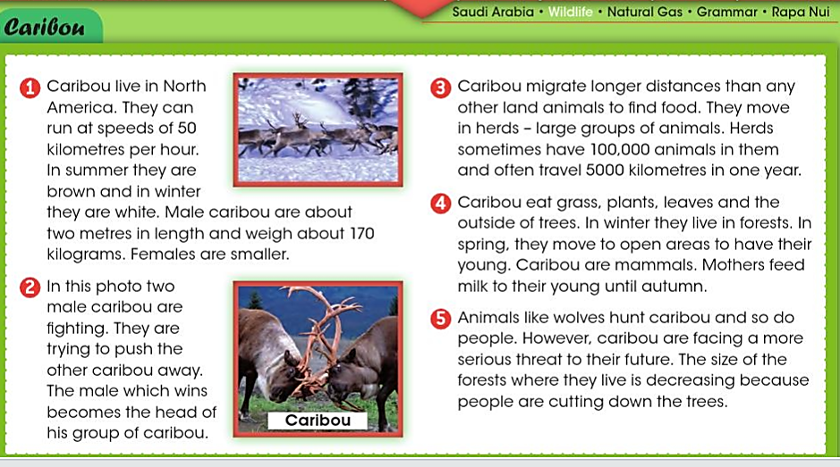
Read this passage then answer the questions below:

Answer this questions :
- What do caribou eat ? …………………………………………………………………………
- Why do caribou go long distances ? …………………………………………………………
- Where do caribou live ? …………………………………………………………………………
What do these words mean :
- Mammal …………………………………………………………………………………………
- Herd ……………………………………………………………………………………………..
- Threat ……………………………………………………………………………………………
Complete :
- Caribou are facing three threats a-……………………….. b-……………………………………...
. c-………………………….
- Caribou often travel …………………… ……………………………… in one year .

Good luck


Name _______________________________________ class 3\_______________
1-Write a paragraph about Eid Al Fitr these will help you :
celebrate - special food – clothes – poor people – spend – small gifts

We celebrate Eid Al-Fitr after Ramadan . We eat special food . We wear smart clothes .we help
poor people by money . we spend lovely time with our family . we give small gifts to the children .

_____________________________________________________________________________________
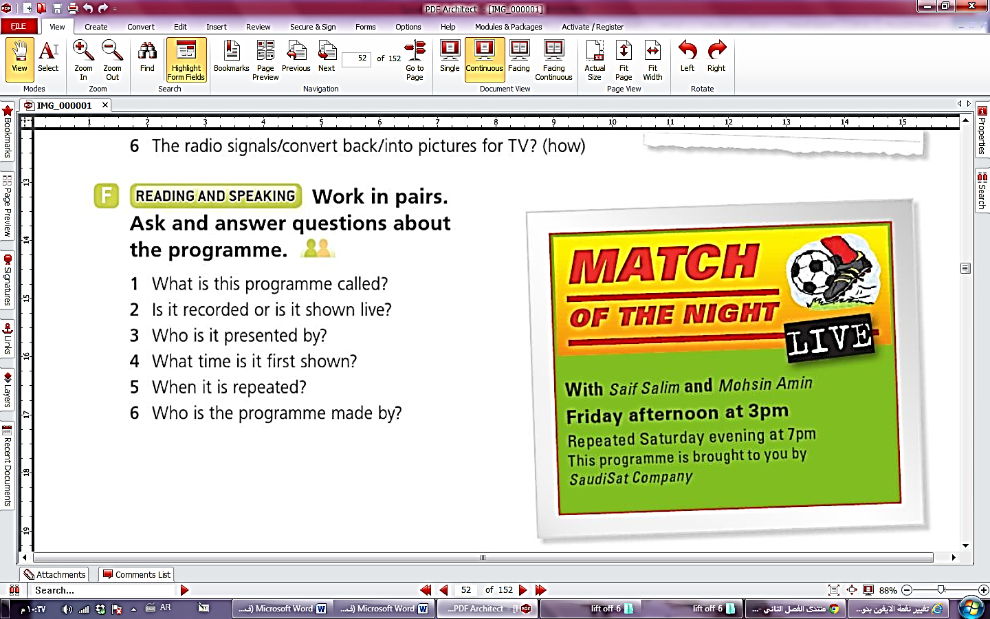
2-Write a paragraph about This programmer
thesewords will help you :
This programme is called Match of the Night .
It’s shown live.It’s presented by SaifSalim
andMohsin Amin.It is first shown on
Friday afternoon at 3pm.It is repeated
on Saturday evening at 7pm.It’s made by
the Saudi Sat company

Note
…………………………………………………………………………………………………………………………………………………………………………………………………………………………………………………………………………………………………………………………………………………………………………………………………………………………………………………………………………………………………………………………………………………………………………………………………………………………………………………………………………………………………………………………………………………………………………………………………………………………………………………………………………………………………………………………………………………………………………………………………………………………………………………………………………………………………………………………………………………………………………………………

