hours Time: 2 بسم الله الرحمن الرحيم Kingdom of Saudi Arabia Ministry of Education Date: \ \1434
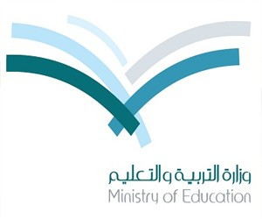
اختبار الفصل الدراسي ) الثاني( intermediate0000000000
للعام الدراسي 1434 – 1435هـ School

المادة : لغة إنجليزية الصف: الثاني متوسط : ( ) رقم الجلوس :
اســـم الطالب: ………………………………….

30

Read the passage then answer the questions:
There are different kinds of maps: like the world map, the city map and the road map. We use directions on a map to show us places. The main directions are east, west, north and south. A compass rose is used to see the directions.
Maps also show sizes, climate and physical features. Signs or symbols are used to
show things on the maps. Symbols place words by pictures to make the map easier to understand. These symbols are shown in a small box called the 'key' or 'legend' given on the side of a map.

1- The suitable title for this paragraph is :
a- Road signs b- Map reading c-main directions d- a compass
2-The main directions are:……………
- map, compass, north and south.
- climate and physical features.
- east, west, north and south.
- the city map and the road map..
3- The compass rose tells us……………………….
a- climate b- distance c- Time d- directions
4- Symbols are shown in a small box called the…………….
a- compass b- Symbols c- sizes d- key …………………. is a kind of maps. 5-
a- city map b- compass c- north and south d- climate
6- Khalid : Why were you absent yesterday?
You : Because, I was……..
a-13years b- ill c- student d- tall
7- Khalid : What was the matter ?
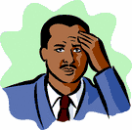
You :I have got……………………………
a- cough b- headache c-chickenpox d- flu

8-Sunday comes ………… Saturday .
a- past b-of c- over d- after
9- Sami has a test tomorrow.
a. He must sleep early b. He must slept c. He must sleeping
10 . Abha is ……………than Jeddah.
a. cold b. coldest c. colder d. cold than
11-……….. Mohamed at the clinic yesterday ?
a. Were b. Was c. Are d. Is
12- Ali is ………………… student in the class .
a. short b. shorter c. shortest d. the shortest

13- My friend writes his homework…………….
a. care b. carefully c. careful d. slow
14- Sami buy a gift for his brother.{ the direct object } (D.O) is………………..
a. his brother b. Sami c. buy d. a gift
15-Choose the correct opposite:
more # less more # less more # less
good # better good # small good # bad
a. big # old b. big # new c. big # small
late # early late # early early # late

16 The Red Sea is 2,253 km long. ………………………………………………………………
a-How is long red sea ? b-How long is the red sea ? c-How red sea long is?

17-Go past the mosque……………..

a. b. c-

18- This traffic sign means……………..

a. turn right. b. Dead end. c. U turn left. d. Don’t enter. 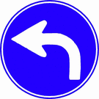
19- Pharmacy is a place where you buy…………..

a. flowers. b. medicine. c- food. d- clothes.

20- He feels …………
a. backache. b. cough. c. dizzy. d. sunstroke.
21- “Exhibits” means …………… .
a- things you see b- places you go to c- flags you can buy
22- He is a ………………… boy.
a- shy b- happy c-sad d- naughty
23- Cold, headache and food poisoning are -----

a- Shapes b- Illnesses c- Places d- signs

24- proud, means ……………………………………………………
a- to be unhappy and sad b- to behave very bad c- to be pleased by something
25- The longest river in the world is ------
a-The Amazon b-The Mississippi c-Nile d-Euphrates

26- Calm down means ………………
a. stay relaxed b. be happy c. get angry d. go home

27- Jeddah is called the ……………..of the Red Sea.

a- Bride b- moon c- sun d- mall
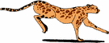
28- …………….,is the fastest animal in the world.
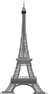
a. shiitah b. TCheetah c. Cheetah d. sheetah 29- ...iffel Tower is most famous Tower in the world .
a. Tiffel b. Eiffel c. Fiffel d.Siffel
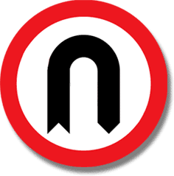
30- This sign means …………turn
a. U b. N c. R d. p

31- a. skuare b-square c-stuare d-scauare

Choose the correct letter:
32- chic-en pox A- g B- k C- a D- q

33- dead e_d A- l B- u C- n D- v

34- ci_cle A- i B- d C- t D- r

35-talk-ave A- t B- a C- m D- s
Match column A with column B

B |  | A
In Jeddah . | a | 1- In which lesson do we use maps?
7 | b | 2- Where do you see the road signs?
I have earache. | c | 3- What is the matter ?
on the road. | d | 4- Where is the highest fountain in the world?
geography. | e | 5- How many continents in the world?

- Choose True or False:

1- Ahmad and Ali like fishing. ( T ) ( F )

2- did ali WAtcheThe News . ( T ) ( F )

3- what iS Your Name . ( T ) ( F )

4- he isfrom makkaH ( T ) ( F )

5- We love our country very much . ( T ) ( F )

