

Student’s Portfolio.
Name : ……………………………………………
Class :………………………….

5


10
Page 5 |  | Page 20
Page 8 |  | Page 23
Page 9 |  | Page 26
Page 13 |  | Page 28
Page 15 |  | Page 30
Page 15 |  | Page 33
Page 16 |  | Page 34
Page 18

CURRICULUM VITAE( CV)
Name :…………………………………………………………………..
Age: ……………………………….
Nationality: - ........................................................

Religion: - .............................................

E-mail: .............................................................................................

Phone: .....................................................................
Address: ...................................................................................................
Skills : ...........................................................................................................
.........................................................................................................
Hobbies:........................................................................................................
................................................................................................
Best book or movie : …………………………………………………..
Courses Attended :.....................................................................................................
..........................................................................................
Wisdom You Like : ....................................................................................................
................................................................


Module 1
1a What’s up !
How do young people today keep in touch with friends &family ?


Write notes .




Draw your idea about keeping up with friends and family ….

1b/Keep in touch.


Advantages &disadvantages :
……………………………………………………………………………………………………………………………………………………………………………………………………………………………………………………………………………………………………………………………………………………………………………………………………………………………………………………………………………………………………………………………………………………………………………………………………………………………………………………………………………………………………………………………………………………………………………………………………………..

Unit Project 1.
Build a dialogue about communications now and in the past .
...........................................................................................................................................................................................................................................................................................................................................................................................................................................................................................................................................................................................................................................................................................................................................................................................................................................................................................................................................................
................................................................................................................................................................................................................................................................................................................................................................................................................................................................……………………………………………………………………………………………………………………………………………......................................................................................................................................................................................................................................................................................................................................................................................................................................................................................................................................................................................................................................................................................................................................................................................................................................




1c That’s me.
Imagine you are having a dialogue with your mother about clothes .
…………………………………………………………………………………………………………………………………………………………………………………………………………………………………………………………………………………………………………………………………………………………………………………………………………………………………………………………………………………………………………………………………………………………………………………………………………………………………………………………………………………………………………….…………………………………………………………………………………………………………………………………………………………………………………………………………………………………………………………………………………………………………………………………………………………………………………………………………………………………………………………………………………………………………………………………………………………………………………………………………………………………………………………………………………………………………….



Use the following phrases .” 3 “
big fan of / can’t stand / be fond of / be into / find ….boring.

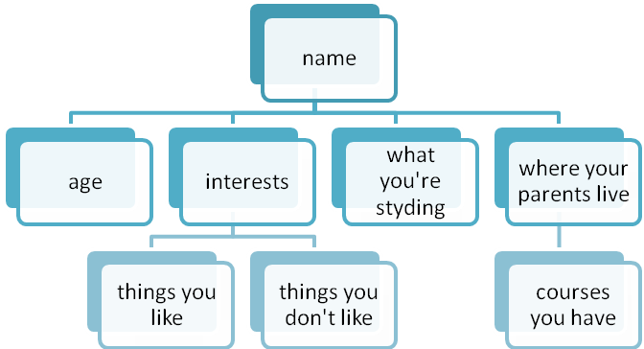
You are applying for a part-time job at a private school. Tell the principle something about yourself .

………………………………………………………………………………………………………………………………………………………………………………………………………………………………………………………………………………………………………………………………………………………………………………………………………………………….………………………………………………………………………………………………………………………………………………………………………………………………………………………………………………………………………………………………………………………………………………………………………………………………………………………….………………………………………………………………………………………………………………………………………………………………………………………………………………………………………………………………………………………………………………………………………………………………………………………………………………………….………………………………………………………………………………………………………………………………………………………………………………………………………………………………………………………………………………………………………………………………………………………………………………………………………………………….

1d Good role model .
In your opinion , why do you think he is a role model ?

Scan the passage for the following information :
1- Name of a person . ………………………………………….
2- Name of a sport . ………………………………………
3- Names of years . ………………………………………..
4- Nationality . …………………………………….
5- 3 countries . …………………………………………………….
…………………………………………….
6- Name of a championship ……………………………….

Answer the questions below :
1) Where did Ed work in the past ?
2) How did he explore the Amazon River ?
3) Was his job easy ?
4) How did he educate people ?

Do you know any famous people ….or good models ?
Write their names and achievements . Why do you think they are role models .
1)

2)

3)


1e-Friendly faces .

Write 4 sentences using adjectives that describe personalities about your brothers , sisters ,mother or father .
- ..................................................................................................................................................................................................................................
- ..............................................................................................................................................................................
- ............................................................................................................................................................................
- ...................................................................................................................................................................................................


Write a description of a person you have met .

.....................................................................................................................................................................................................................................................................................................................................................................................................................................................................................................................................................................................................................................................................................................................................................................................................................................................................................................................................................................................................................................................................................................................................................................................................................................................................................................................................................

2

Culture page .
KAU.
Write T or F
1- KAU was established as a general university . { }
2- There are two campuses for male students only .{ }
3- The university aims to offer higher education to all students . { }

Module 2
2a- What happened .



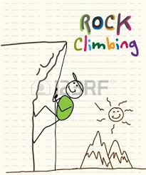

Activity . | Kind .
1-mopping the floor .  2-doing the washing up.  3-sightseeing  4-scuba diving .  5- hovering .  6-rock climbing .  7-horse riding .  8-cycling .  9-hiking.  10-taking a cooking course. | …………………………………………  ………………………………………….  ………………………………………..  …………………………………………  ………………………………………….  ………………………………………..  …………………………………  ……………………………………  …………………………………..  …………………………………….

Project .
Read the passage at home and complete the concept web with the following .
- Main ideas
- Sub-ideas
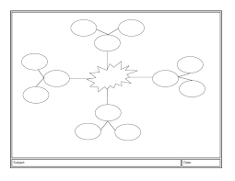

You can make your own map.

2b Just taste it


A new experience .

----------------------------------------------------------------------------
Lemon – mango – chocolate – banana – dark chocolate – curry – chips – Arabic coffee – hot sauce – vinegar –yogurt – sugar –salt-

Classify the words .
You can add new classification .

Sweet | Bitter | Salty | Spicy | Fresh | sour | ? | ?

2c- Believe it or not .

Insects .
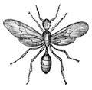



--------------------------------------------
Listen to the conversation and predict what would happen next .

Listen and underline the words you hear .
Swarm – faint – sting – hospital – kill – flowers – hide – buzz- police – honey – river

Listen again and choose the correct words :
- The story happened to …. a-Sam b- Joe . c- a friend .
- …………………….killed the bee. a-Sam b- Joe . c- a friend .
- Bees ……………….people . a- kill b-sting c- wound .
- The man hid …………the river . a- under b-above c- beside

Do you believe the story ? Why?
…………………………………………………………………………..
What would you do if a swarm of bees came after you ?
……………………………………………………………………………

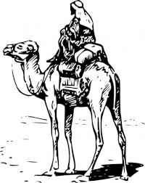

2d- Adventure .

Topic :……………………………………………………
What I know | What I want to learn . | What I have learned | Note.

Write the main ideas of the passage :
1-………………………………………………………………………………………………………….
2-………………………………………………………………………………………………………..
3-……………………………………………………………………………………………………….
4-……………………………………………………………………………………………………….

2e\ Broaden your mind.
Write an e-mail to your friend telling her about a new experience you have had lately .
Complete

Greeting | Set phrases for beginning paragraphs | Set phrases for closing paragraph . | Signature  Ending
Hello  Hi | How are things ?  How’s life ?  How are you ? | Well, that’s all foe now . | Yours


- Start with hi\ hello …
- Use set phrases to begin.
- Use set phrases to end .
- Sign off with a set phrase.
- Use the short form .

2

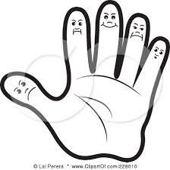
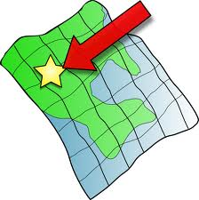
Module 3
3a What’s your destination?
Read the passage and complete the following



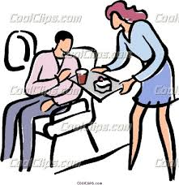
\

( steward ) ( stewardess )
Guess the meaning of the following :
1- arrivals . | a- leaving a place . b- reaching a place . c- stay in a place .
2- landed . | a- stayed in the air . b- returned to land . c- flew away.
3-departure . | a- leaving a place . b- reaching a place . c- stay in a place .
4-delay . | to happen … a- now b- later . c- before
5- took off . | The action of …..a- landing b- flying c- staying .
6- gate. | an opening in the a- window b- wall c- ground .
7-board | To get …. a- into or onto a plane . b- under the plane c- above…
8- boarding card (pass) | a card that helps to…a-leave b- board c-stay in ….. a plane .
9-flight attendant . | A person who.. a- drives a plane b- serves passengers c-clean a plane.

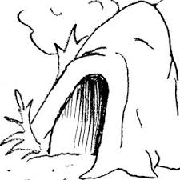
3b/ Dos &don’t .
Read the passage and write down the main ideas of each paragraph :
Number of paragraph . | The main idea :
First paragraph .
Second paragraph.
Third paragraph .
Fourth paragraph . | 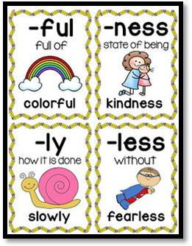
Fifth paragraph.
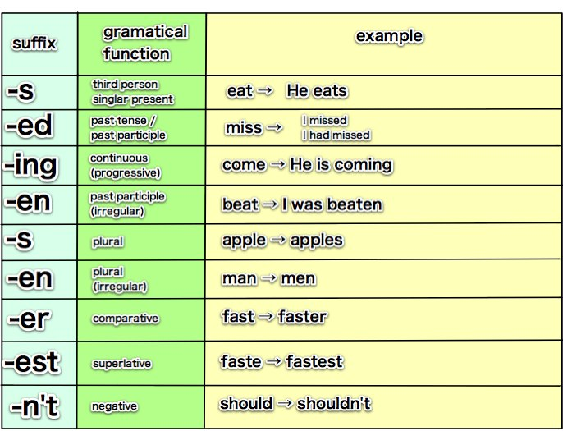

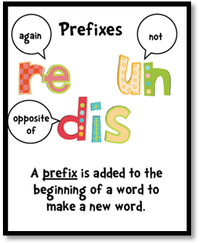

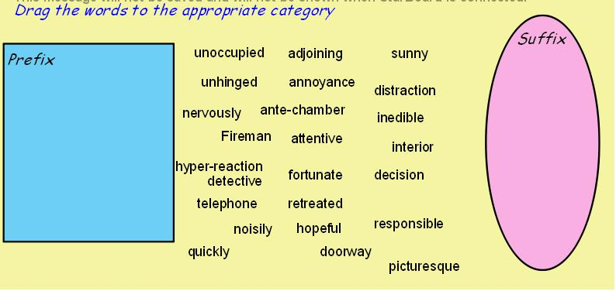
Project .

3cWhere to stay.
You travelled to Paris . You are at a tourist info centre . You want to know about different places there . Ask dirct questions about the following information .
Hotels – weather – sightseeing – cost of underground tickets .shopping centers –cinemas –outlet – ( any information )


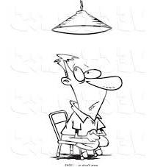

Hot seat.

You are travelling to London this summer and you want information about ( accommodation , the weather , shopping , interesting places ….) .So write an e-mail to your friend and ask direct questions about the topic .

The tips will help you write the e-mail.

3d- Nature beauty .Frayer model.
Information about the city .
Sights in the city .

Sichuan .

Chengdu .
Food.

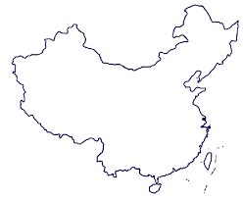
Where is Sichuan ?

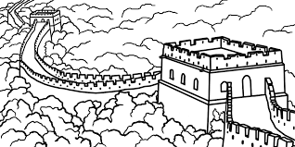

3e/ Urban life.


You live in Madinah and you love the city. It is the city of Prophet Muhammad and his followers .Write a paragraph to describe the city and things you like about it .

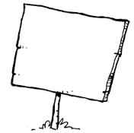
Ideas :
Before you start .
1) Write down some ideas.
2) Develop your ideas .
3) Use a variety of adjectives to describe the city .


Module 4 Nowadays.
How is life differentnow from ten years ago ?

4a/Is it worth it ?


1- Where are the two men ?
2-What are they talking about ?
3-How much is it ?
4- What is it called ?
5-Why did he invite his friend ?

Use the confused words in sentences :
- Broke ;
- Short ;
- Lend ;
- Borrow;
- Note ;
- Coin ;
- Bill;
- Receipt;
- Afford ;
- Save ;

4b/ Only time will tell .
Make a brochure about 5 ideas that will change the future in your own opinion .

2

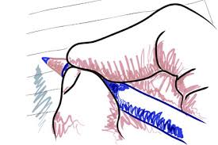
4c/ Aquick note .
Rewrite the following notes using abbreviation .
1) visit my friend as soon as possible
2- Go to Salam Road .
3- Please turn to page number 20 .
4- The garage is on Sultana Street .
5- the meeting is after an hour and 30 minutes .
6-find Doctor Manal telephone number.
7-Arrival is Monday 23 September.
8-Weight is 50 kilogram .

4d/ What an idea!
Use pictures .

2

Make a brochure about 10 ideas that changed women lives .

4e/ Can you live without it ?
Nowadays people use social medias like twitter , face book path and others a lot .
Do you think these applications are useful ?
Do you think it is good to depend on them for communication ?
Debate this idea with your classmates .
Advantages . | Disadvantages .
 | 

Speak in a low voice.
Do not shout .
Wait your turn to speak.
Use:
- I agree.
- I disagree
- You’re right.
- I think…
- That’s not what I think




5a\ How are you feeling ?

- Listen to the three dialogues and answer the exercise below :

1- Mr.Ammar came to surgery to … |  | - be examined . b- make an appointment .  c- be checked .
2- Mr.Ammar wants another … |  | a- appointment b- doctor c- prescription .
3- The doctor gave hime …to stop the pain . |  | a- fluids b- painkillers. c-medicine .
B)Decide if the sentences are ( T ) or ( F )
1- The patient saw the doctor on the same day. |  |  | a-T b- F
2- The patient had allergy . |  |  | a-T b- F
C) Guess the meaning of the following :
- booked up .
- hang on
- run out of .
- get over .
- take away.

How many times were these words mentioned ..
Schedule . ( )
Allergy . ( )
Wedding . ( )




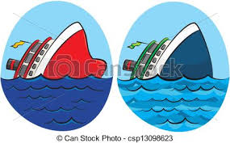
5/b When in danger .
What would you do if were in danger ?

Frayer model.
History of communication :
Development of communication means

S.O.S

More information :

More information :

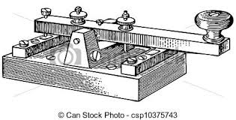
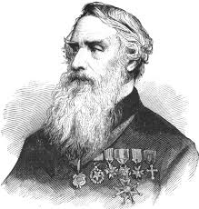
Morse code is a method of transmitting text information as a series of on-off tones, lights, or clicks that can be directly understood by a skilled listener or observer without special equipment.

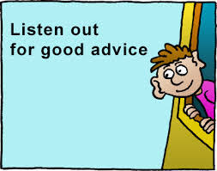
5c/ A word of advice.

Try to guess the meaning of the words in bold :
1- suffer from . | ( ) | - to take action in order to solve a problem .
b- control . | ( ) | - to have power over sth / sb.
c- reduce . | ( ) | -to be affected by an unpleasant condition .
d- a fear of . | ( ) | -decrease , make smaller or less.
e- deal with . | ( ) | - be afraid of.
f- advise . | ( ) | -to tell sb what they should do or how they should act.

Write a short letter to a magazine problem page describing a problem you have and ask for advice .




5d / In the news.
Read the passage and write the main ideas:
Paragraph . | Main idea.
First paragraph .
Second paragraph .
Third paragraph .
Fourth paragraph.
Rewrite the following in the passive voice as news headlines.
1- A bus driver drives a bus fast.
2- 100 students took computer courses .
3- The Saudi government helped Syria.
4- Children learn alphabets fast.


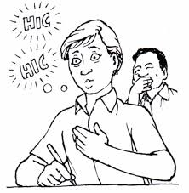
5e / That’s not funny!
Write an account of a true story .First , answer the questions below :
1- When and where did the event take place ?
2- How did the writer feel during and the end of the experience ?
3- What is the purpose of each paragraph ?
4- Which tense does the writer use .
5- Which linking words does the writer use and why ?


Important tips :
- Use the first person ( I , we )
- Divide your account into paragraphs .
- Try to make the story interesting .
- Use variety of adjectives .
- Use adverbial phrases like ( suddenly , fortunately , unfortunately , to my surprise ….)
- Use direct speech .

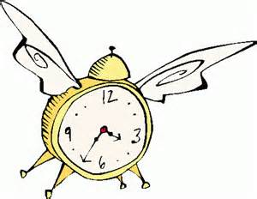
Module 6
Time out .
What do you usually do in your free time ?


6a/ Feeling sporty ?





6b/ Thrills and spills .

Make a brochure about a holiday you are planning to have .
You’re staying for 5days .
Use clipart to make your brochure beautiful .

2




6c/ Hot spots .
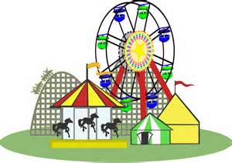
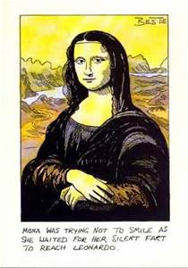




6d/ It’s show time

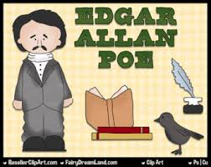

2

6e/ Food for thought .

The title | Author | Plot | Ending
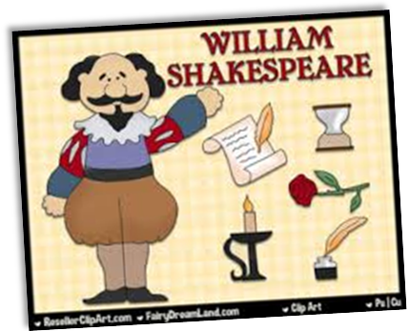


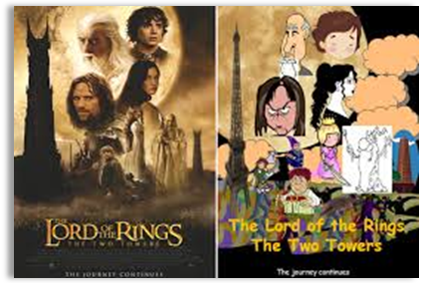

Text criticism.
 | Lesson no. | I like | I don’t like
Module
1
Module
2
Module
3
Module
4
Module
4
Module
5
Module
6

4

