Reflexive pronouns
myself | 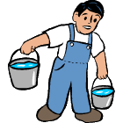
yourself
himself
herself
itself
ourselves
yourselves | He carries the buckets himself.
themselves

each other | 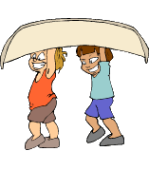
 | They help each other.

