
Revision Unit 6.. The Future 2nd grade secondary

1- write the name of the category :
a-[ --------------------------- ] : vaccine against a polio , cure for cancer
b-[ --------------------------- ] : weather control , protection of endangered species

2-
Future perfect: action which will be completed in a specific time in the future
In ( time ) , (will- might- should) + have + 3rd (v)
In 2030, we will have travelled to space
Might possibility , should probability , will certainly
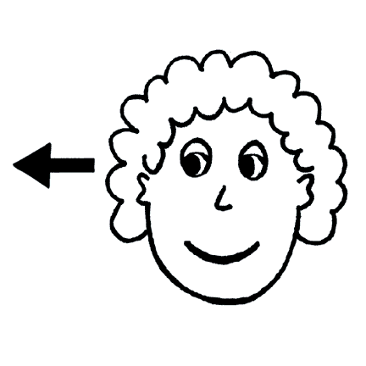

Correct the verb between brackets :
a- In 2016, we ------------------------------------------ ( return to) my country , Saudi Arabia.
b- In 2050 , people ------------------------------------ ( invent ) time travel.
c- By the time I’m 60, ---------------------------------- ( have ) a lot of interesting experiences .

3- Match the words with their meanings :
a- To create - speed
b- rapidity - to make
c- to protect - to keep away from
d- to avoid - to take care of

4- Choose the correct words under the pictures :
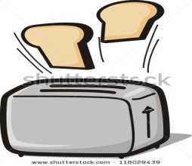
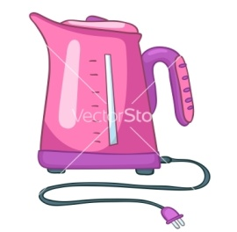
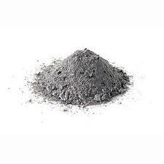

a-( ashes-cuisine ) b-( kettle- rice maker ) c-(toaster – bread maker )
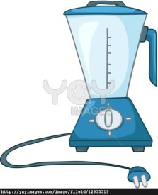
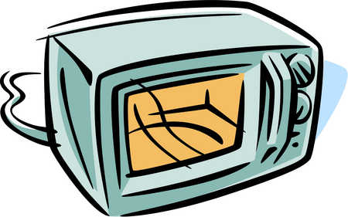

d-(juicer – blender ) e-(microwave- pot)

5-
Clauses of Purpose :
so that I prepared lunch so that I could get to my lesson on time
To I use the kettle to boil water

Do as shown between brackets :
a- I took out a knife . I wanted to chop some onions. [ use (to ) with the clause of purpose]
----------------------------------------------------------------------------------------------------
b- I watched food programs. I wanted to get some inspiration for some new meals .
[ use ( so that ) with the clause of purpose]
---------------------------------------------------------------------------------------------------

6- choose the correct answers :
a- I go to the shopping mall to ( buy – buying ) a new dress.
b- I travelled to Makkah so that I ( could- can ) perform Omrah .
c- In 2010, we ( will move – will have moved ) to our new house.

7- Comprehension :

a- Where is the following text taken from ?
------------------------------------------------------------------------------------------------------
b- What should you do with your blender after using it ?
-------------------------------------------------------------------------------------------------------
c- How should you process meat ?
------------------------------------------------------------------------------------------------------
d- List two things you should not do with your blender ?
------------------------------------------------------------------------------------------------------
e- Why you should not reach into the blender with your fingers ?
------------------------------------------------------------------------------------------------------
f- give two things you would use a blender for ?
-------------------------------------------------------------------------------------------------------
g- underline 3 instructions in the text written by using the imperative form ..

8-Dialogue : Asmaa and lama are talking about the Space Odyssey ..
Asmaa : What is the Space odyssey ?
Lama : ------------------------------- for the director --------------------------------------------
Asmaa : Ah.. I remembered it .. it is about a computer called -----------------------------
Lama : yes , you are right . the computer had the ability to -----------------, ------------------,
----------------- and -----------------------------------
Asmma : It had a very ------------------------------ ending when they disconnected the computer
and it --------------------------------------

9- Choose the correct answers :
a- The 19th century was the era of : [ industrialization – communication ]
b- [ Alternative energy sources – medicine ] like : wind and solar power .

10- Composition : Write your own plan for continuing to develop your English : [5 sentences only]
------------------------------------------------------------------------------------------------------------------------------------------------------------------------------------------------------------------------------------------------------------------------------------------------------------------------------------------------------------------------------------------------------------------------------------------------------------------------------------------------------------------------------------------------------------------------------------------------------------------------------------------------------------------------------------------------------------------------------------------------------------------------------------------------------------------------------------------------------------------------------------------------------------------------------------------------------------------------------------------------------------------------------------------------------------------------------------------------------------------------------------------------------------------------------------------------------------------------------------------------------------------------------------------------------------------------------------------------

Prepared by
Teacher ..Bushra Assiri

