Quiz : 2 Second Year Term 2 Name : ………………………………………………………….. Class 2/ …….
1-Grammar : Choose :

1-This time next year , I will ( be / be being /have began/have ) on holiday.
2-If people paid more attention to the environment, the beaches ( will be /would be /would have / were ) cleaner.
3-Ahmad , you ( need /needn’t/don’t have to/must)go now . A taxi is waiting outside .
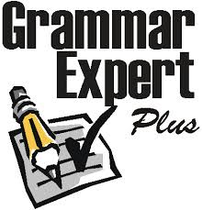
4-Many people suffer ( form / to / out / with ) allergies.
5-If I stay under the sun for too long , I ( am burning / burned/ burn /would burn ).
6-He has been managing the company (since / for / already /before ) three years .
7-I try to keep ( in / out / with / for ) touch with my classmates .

2-Vouclabury : Choose :

1-Hassan has nearly completed his Marketing ( course / subject /award /certificate ).
2-I prefer buying my books online because it`s more ( convenient / advanced /remarkable /inevitable ).
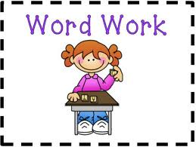
3-Incorrect means ( wrong / right /clear / amazing ) .
4-Out of the ordinary means ( important / unimportant /usual / unusual ).

3-Match :
1- Caught my eye a- You failed to mention that …. ( )
2-It isn`t all like what you say b- give a catchy title . ( )
3-When writing a complaint letter c-attract one's attention. ( )
4-When writing an article d-be firm but polite . ( )

4-Read then put ( T ) or ( F) in front of the sentences :
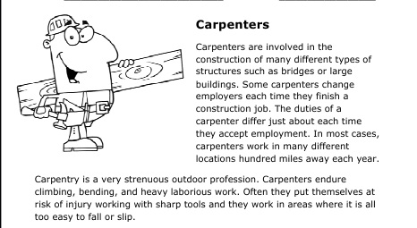

1-Caprpenters put themselves at risk . ( )
2-They work in areas where it is difficult to slip . ( )
3-The duties of carpenter differ each time . ( )
4-They work in many different locations . ( )
5-Large in line 3 is the opposite of heavy . ( )
6-Caprnters used iron in their work . ( )

