Name :……………………………………… Class…………………

A- Answer
1- What is your favourite hoppy ?
………………………………………………………………..
2-Choose:
What do you do in the weekend ?
a- drawing. B-math c- doctor.

What time is it ? It is ………… 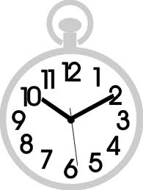
a- ten o'clock b-quarter to ten c- ten past ten

B) Choose the correct word:
1-[Do \Does ] she like reading?
2-They ( watch – watched – watching ) tv last night .
3-Can they [ play\ playing ] tennis?
4- He ( went – go – goes ) to school yesterday .

B) Ask yes\no question:
Huda is cooking dinner……………………………………………………………..

C) Change into negative
He can read. ………………………………………………………………………………..

C) Write the words under the correct pictures:

1-cooking / 2- sew / 3-reading / 4- collect shells / 5- drawing

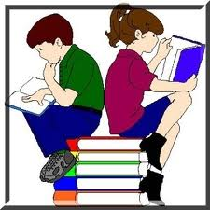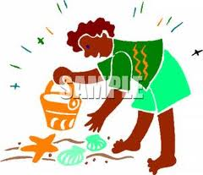

……………… …………… ……………… …………….

D) Copy:

Helping others is your duty.

