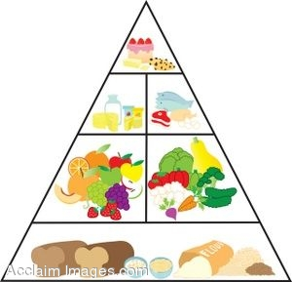
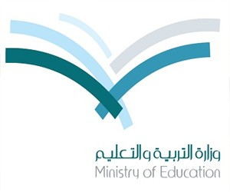

Kingdom of Saudi Arabia Month Exam
Ministry of Education Time: 45 minutes
21st Intermediate school First Grade

Read the following passage then, answer the questions
There are four main food groups . Bread , cereals , rice and macaroni are in the first group . They give us B vitamins and starch . Fruit and vegetables are in the second group . They give us vitamins A and C. Milk , butter , cream , cheese , and yoghurt are in the third group . They give us vitamins and calcium . Meat , fish , eggs , beans , and nuts are also in this group.

10

Name:……………………………………..Class:……………Date:…………

1

A)_ How many food group are there?....................................................................
B)_ PUT {T} OR { F}:
1- Milk and Cheese give us calcium { }
2- Fruit and vegetables are in the third group { }
2
Number the balloons togive the correct order :



TT

Choose :
3
1) Is there ( any – some ) coffee ? .
2) There is (an – a – any) banana on the table
3) I reach school ( in – on – at ) 6 : 30 a.m.
4) Huda ( wake up – wakes up ) early every morning .
.
Do as shown between brackets :

I go to school on Friday . { Add never and re-write the sentence}
……………………………………………………………………………………………………
4
Match :
1- a cup of ( ) coffee
2- a bottle of ( ) bread
3- a piece of ( ) clock
circle the odd word
1- beef- lemon – fish – chicken
2- flour – bread – rice – eggs
5
Copy the following sentence once :

You must keep your classroom tidy
………………………………………………………………………………………………………………………………………………………………………………………………..…………………………………………………………………..…..………………………..………………..……………………

6
Write the word :
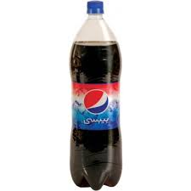
GOOD LUCK
T.AFAF

………………….

………………….

