Write the correct word under each picture :
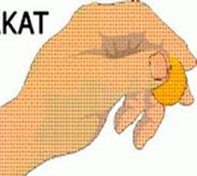
( alms /pray / poor / fasting /prayer mat/pillar)

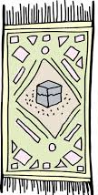


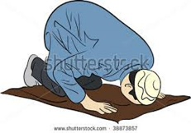

…………………… ……………………… …………………… …..………..…… ………………… …………………

Use ..have to :
1-pray on time .
………………………………………………………………………………….
2- Read Holy Qura'an every day .
………………………………………………………………………………….

Choose :
1- I ( have / has ) to study hard .
2- You have to speak English in the class .
3- Linda ( have / has ) to sleep early .

E.T :Lamia Al-Fadil

