Name: .............................................................
Class: 1 / ..............

~~~~~~~~~~~~~~~~~~~~~~~~~~~~~~~~~~~~~~~~~~~~~~~~~~~~~~~~~~~~~~~~~~~~~~~~~~~~~~~~~~~~~~~~~~~~~~~~~~

A- Choose and complete:

a dress - What - It's yellow and white - wearing

What's Fatimah ..................................?

She's wearing ....................................

................................. colour is it?

.....................................................................


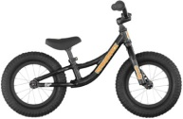
1

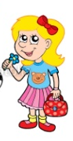
B. Choose :
1- It's ........................ bike. [ her - his - their - our ] 2
2- It's ........................ bag. [ her - his - their - our ]
3- .......................... colour is it ? [ When - What - Where - How ]
4- The camera is ............... the garden. [ in - at - on - an ]
5- ............................... computer's small. [ fatimahs - Fatimahs - Fatimah's ]



6- ....................... are red apples. [ We - She - It - They ]
7- Is this Nina's book ? ..................., It's Reema's. [ Yes - No - Ok - Hi ]
8- ....................... is the T.V ? It's in the bedroom.
[ When - What - Where - How ]

C. Write correctly:
1- its Fatimahs computer. ...................................................................
2- her hairs long ...................................................................

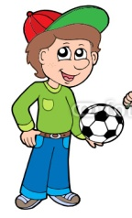
D- Write:
1- Whose ball is it? .......................................................... Omar
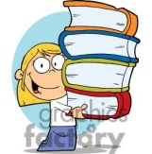
2- Whose books are they? ........................................................
Suzan

R | ....
.... | w
Q | ....
.... | n
X | ....
.... | t
E- Complete:

F. Choose the odd word in each group :
DVD player
TV
Mobile Phone
bedroom
computer
kitchen
bathroom
living-room

G. Match the words with the right pictures :

dress - soldier - house - camcorder - blouse - dentist - skirt - scarf

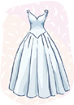

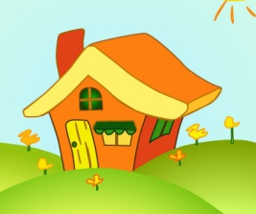
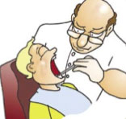

1- .............................. 2- ............................... 3- ............................. 4- ............................
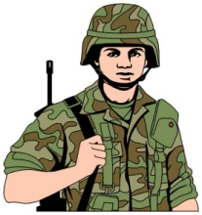
.
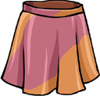
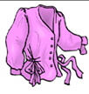


5- ............................... 6- ................................ 7- ............................... 8- ..............................

