
Unit ( 1 ) Lesson ( 1 )
سبحان الله و بحمده سبحان الله العظيم
My Name …………………………………………………………………………………………………………………………………………..

Q 1: Write the correct word under each picture :

( teacher - school - student - friends )


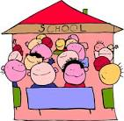


…….… ….…… …..…… ……....

Q 2: Choose :
1- She ( is having – had ) an exam tomorrow .
2-We ( is having- had ) a lot of work last week .
3- ( Tomorrow – Yesterday ) he had a party .

Q3: Complete :

chair - year - there - ear

We're | Where

