First Intermediate final exam2nd Term ( 1st session )

__________________________________________________________________________________________________
المملكة العربية السعودية |  |  الصف : الأول متوسط
وزارة التـــعــــليم |  | الدور الأول للفصل الدراسي الثاني
الإدارة العامة للتعليم بالمنطقة |  | لعام 1435 - 1436
مدرسة المتوسطة  اختبار مادة اللغة الانجليزية |  | الزمن : ساعــتـــــــان  عدد الأوراق : 3 صفحات
………………………………………………………..……………………..………………الاسم :
……………………..…….........… رقم الجلوس #

 | Q. I | Q. II | Q. III | Q. IV | Q. V | Total | Oral
Corrector
Reviser |  |  |  |  |  | 24 | 6

30

_______________________________________________________________

5

I
Composition:

( A )There is a big ZOO in Riyadh. Write a paragraph about it.
Guide words:( district - big - animals - come - birds)

………………………………………………..
…………………………………………………………………………………………………………..
…………………………………………………………………………………………………………..
…………………………………………………………………………………………………………..
…………………………………………………………………………………………………………..
…………………………………………………………………………………………………………..
……………………………………………………………………………………………………………
…………………………………………………………………………………………………………….
P.T.O

( B ) Put the sentences in the correct order:
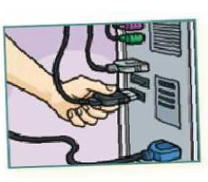
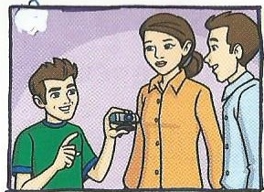
- We’ve got the webcam _____
1
2
- Click the mouse. _____
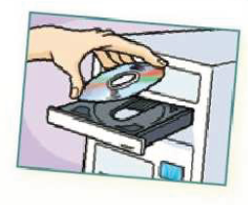
- Plug the webcam in. _____
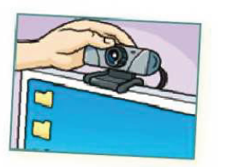
- Put the webcam on top of
4
3
the monitor . _____
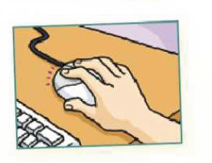
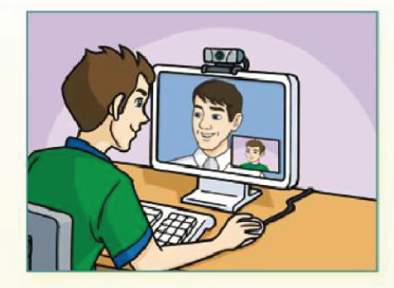
- Use your webcam. _____
6
- Put the CD in here. _____
5

5
Comprehension :
II.
Read the following passage then answer the questions:
Fahad is a student. He is 13 years old. He goes to school at 7 o’clock in the morning and comes back 1 o’clock in the afternoon. His parents love him because he is clever and helps them. Fahad likes English and Math. He wants to be a piolet one day.
A)Answer these questions:
1- How old is Fahad ?
…………………………………………………………….……………..……………………………....…
2- Why do his parents love him ?
Because…………………………………………………………………………………………………..
3- Does he go to school at 5 o’clock ?
……………………………………………………………………………………………………………..

B) Put ☑ or ☒ :
1- Fahad is a student. ( )
2- He comes back at 3 o’clock in the afternoon. ( )

C) Choose the correct answer:
1- Fahad wants to be a ( vet - piolet - doctor ) one day.
2- Fahad likes ( science - art - English ).

____________________________________________________
P.T.O

6
III.
Grammar :
A) Choose the correct answer:
- I like ice-cream .( So do I - So does I - So am I - So do ).
- They live ( at - on - in - over ) London.
- She ( are - is - am -do ) going to be late for school.
- How ( many - much - far - long )apples are there?.
B) Correct the verb:
- He (play ) football last Friday. …………………………….
- He is good at ( swim ). …………………………….….
C)Complete :
1. Are they going to visit Jeddah ?No ,…………………………………………………
D) Give the Plural :
1. Sheep ………………………2. Child ………………………….
E) Write the compartives :
1.Cheap…………………………2. Big ………………………
_____________________________________________________________________________

5
IV.
Vocabulary :
A) Write the words under the correct picture :

Banana/ pound / umbrella / art / hippo /





…………………….. …………….………… …..………………… …………..…………..

B) Give the opposite of the words:
- sad X ……………………. 3. hello X …………………………
2. good at X …………………..... 4. south X …………………………
P.T.O



C)Circle the job :
1. Farmer 2. Doctor
Vet Waiter
Piolet Farmer
Nurse Postman

3
V.
Orthography :
A) Complete the missing letters :
1. Omar hea__ed the ball and sc__red a goal.
2. People h__nted the r__inos.



B) Complete the spelling of the words under the picture:

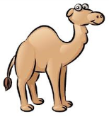
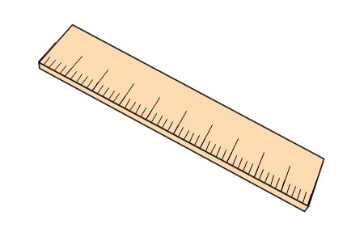
1.2. 3. 4.
Sal__ba__erru__er C__meL

C) Match :
1. gr …… pper
2.co ……ass
3. be ……ins
4. pe ……ll
……gs
_____________________________________________________________________________
End of Questions..

Wish you all the best …

