

Kingdom of Saudi Arabia
Ministry of Education
Al-Ula Educational Zone
1st learning of Qur'an Intermediate school

The Final Exam
First term
First Session
1433-1434 H
First grade

Final exam for 1st Grade intermediate (-1433 / 34 A.H.)
Seat No: ……….................................................................. : s nameۥStudent

Reviewed by | Corrected by | Marks | Question’s No.
 |  |  | Question 1
 |  |  | Question 2
 |  |  | Question 3
 |  |  | Question 4
 |  |  | Question 5
 |  |  | Question 6
________  30 |  |  | TOTAL

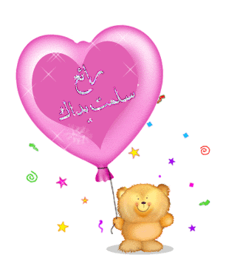

Corrected by: Revised by:

T: Lamia Fadil T:…………………………

( 1 )
Comprehension
Read the following passage then, answer the questions:
Miss Layla is a teacher in a kindergarten. She teaches little children. She has

4
twenty-one students in her class, ten boys and eleven girls. She likes her students; and her students like her. She's very patient and helps them a lot. She's a very good teacher.
A- Answer the following questions:
1- How many boys student are there in the class ?
……………………………………………………………………………………………………….
2- Is Layla a teacher?
……………………………………………………………………………………………………….
B- Choose the correct words:
1. Miss Layla teaches ……………..
a. little children b. young students c. old students
2. She has ten boys and eleven………………
a. teachers b. girls c. farmers
C- Put (  ) or (  ) :
1- Miss Layla works in a kindergarten . { }
2- She has forty student in her class . { }
***********************************************************************
Information Questions

A- Answer the following questions:

6
1- What is the weather like today ?
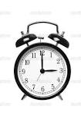
It's ……………………………………………………………
2- What time is it ?
It's ……………………………………………………………….
3- What is your favourite food ?
I like …………………………………………….
B-Choose the right answer:

1- What's the matter ?
□ I'm hungry . □ It's nice . □ I want to sleep .
2- How are you ?
□ Good bye . □ I'm fine thank you . □ I'm 16 .
3- Hi. My name is Shahd:
□ Hi. □ Good morning . □ Nice to meet you, Shahd.
4- What is your father's job ?
□ He is a doctor . □ I have 3 sisters . □ He is sick


C- Put (  ) or (  ) :

1- Omar is Dave's son . ( )
2- Dave's family comes from Britain . ( )

***************************************************
Grammar

A –Choose the correct answers :

5
1- It is ( a - an ) ball .
2- He is ( sleep – sleeps - sleeping ) in the bed now.
3- They have a car. ( Her – His – Their ) car is new .
4- She ( cooks – cook – cooking ) kabsa .
B - Do as shown between brackets :

1- Is it drinking the milk ? {Complete the answer } Yes ,…………………………………

2- never / cola / He / drinks . { Rearrange the sentence }
………………………………………………………………….

3- Thank you for ( help ) me . { Correct the verb }
……………………………………………………………….
**********************************************************

6
Vocabulary

A - Match :
Seasons |  | Nina is Fred's …… | 1
Ice- cream |  | Ibrahim is wearing …….. | 2
thobe |  | I like ……… | 3
sister |  | Summer is a ……. | 4

B- Write the correct word under each picture :
glass – policeman - computer – sunny – kebab -picnic mother cream mom



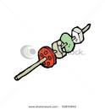




………...…… ................. …....…… .................. ………… ……………

A - Give the opposite : ( never - north – dry ).
1- wet X ………………….. 2- always X ………………………..
( 3 )
Spelling

A- Write the missing letters :

4
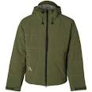 |  |  | 
c...at. | s…n | wi….dy | ….. izza

B- Unscramble the words :

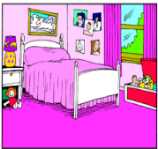 | 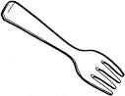 |  | 
romodeb  …………………… | kfro  ………………….. | mareca  ................... | toh  …………..

**********************************************************************************************

5 - Copy the following:

5

. There are chairs in my classroom

We pray in the mosque .

( 4 )

