بسم الله الرحمن الرحيم

إدارة التربية والتعليم بمنطقة الرياض
مكتب التربية والتعليم بـ.........
متوسطة .............................
اختبار نهاية الفصل الدراسي الثاني من لعام 1435/1436هـ للصف الثاني متوسط الدور الأول
اسم الطالب / ................................................................................. الصف / ...................................... الفصل / ................
المـــادة /اللغة الانجليزية رقم الجلوس / ................................... الزمن / ساعتان
الرقم | الــدرجـــة |  | اسـم المصحح | التوقيــع | اسـم المراجع | التوقيــع  Comprehension
الرقم | رقمـًا | كتابـةً
1
2
3
4
5
المجموع
Q 1 /Read the passage and complete the form:-
Last month, Dave Watson stayed at the Black Horse Hotel for 2 weeks. He arrived on 5th January and left on 19th January. The facilities were very old and not very good. Food was tasty and very cheap. The rooms are clean and comfortable. The staff was friendly and smart. Prices are expensive. Room service always came quickly and was very polite.
“Guest Comment Form”
First name: Dave Surname: ………………….
Date of Stay: ……………………. to …………………………..
Number of nights: ………………………………..
Staff Food Room Service
Smart Yes tasty ………….. Fast ……………
Friendly ………….. good value Yes Polite Yes

Rooms Prices Facilities
Clean ………… expensive …………… modern No
Comfortable …………. Good-value No excellent…………

Q 2 /Complete this safety advice use : ( Never – Always )

A- ………………. play with flames or fire .

B-…………………cross the road at traffic light.

C-…………………leave young children alone near the water.

D-…………………eat fruit or vegetables five times each day .

E- …………………play with knives or scissors.

3- Grammar

a. Choose the right answer:
- Ahmad is the [tallest – taller – tall] in my class.
- Ali is (short /shorter/shortest) than Ahmad.

b. change to negative :
- He shuold go to a doctor …………………………………………………………………………..……

c. Give an advice :
- He has a headache ………………………………………………................................................
:::::::::::::::::::::::::::::::::::::::::::::::::::::::::::::::::::::::::::::::::::::::::::::::::::
4-Vocabulary
A. Match:

1- excellent ………..a- to heat water to high temperature.
2-teenage ………… b- a person on a plane, car ,boat or bus.
3-passenger ………….c- between 13 and 19 years old.
4-boil ………….d- very good ,great , fantastic .

B. Write the correct word under each picture:
Classroom- Closet - Teacher - Jacket
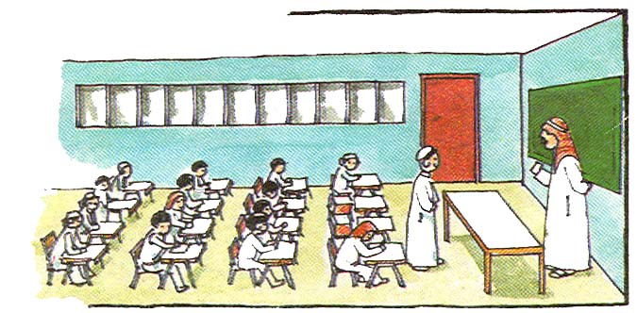
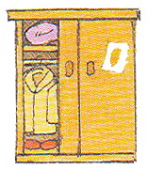
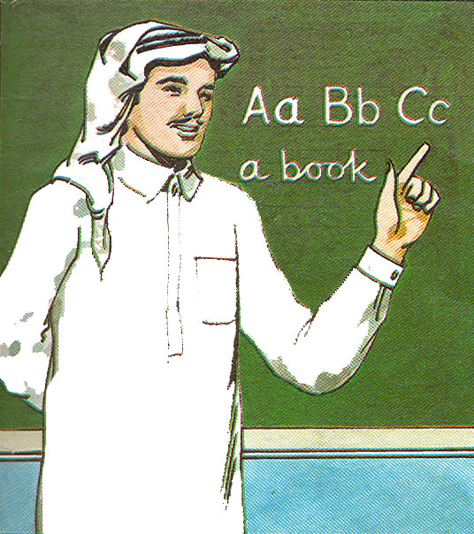
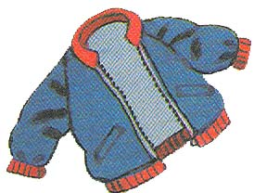

…………….…………………………
……………………………………
……………………………………
……………………………………
::::::::::::::::::::::::::::::::::::::::::::::::::::::::::::::::::::::::::::::::::::::::::::::::::

5-A- Spelling
- Choose then fill in the missing letters:
a - u - m - r

  - Muslims must p__ay five ti__es a day.
  - The to__rists like visiting the Pyr__mids.

……………………………………………………………………………………………………………………………………………………………………….

B- Handwriting

- Copy the following twice:

A friend in need is friend indeed.
2)
1)

- انتهت الأسئلة -

