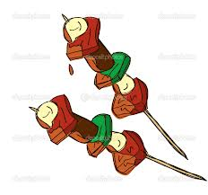
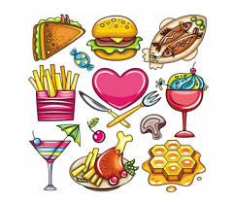
Revision Unit (5 )
My Name …………………………………………………………………………………………………………………………………………..

Q 1: Write the correct word under each picture :
( skewers – pepper - lamb - list - salt - onion - quarter - grill garlic – spinach – list – pineapple )
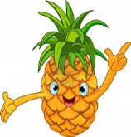
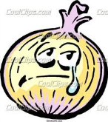
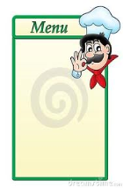
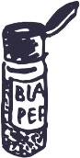
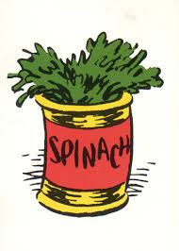
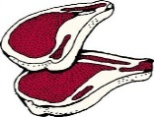

…….. ….….. …..… ……... ……… ……..
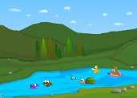
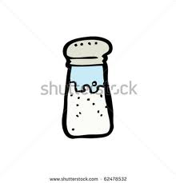
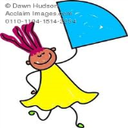
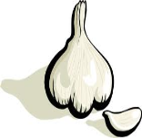
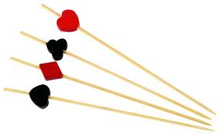
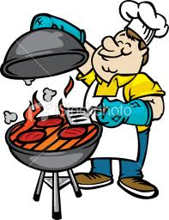

……… …....… …..…... ……… ……. ………

Q 2: Underline the countable word & Circle the uncountable

Books – salt - chicken - olives - lamb - onion - tea – coffee – pizza .

Q3: Choose & Complete :
( lake - trip – permission - waterproof – foreign - dish )
1- Kebab foreign meal
2-Pizza Saudi dish .
3- rain coat mother permission
4- visit friends water proof
Q3: Choose :
1- How ( much – many ) book do you read ?
2- I want ( some – any ) rice with chicken .
3- This is her dress . It's ( his – hers – ours )
4- How ( much – many ) rice do you need ?
5- I don't want ( some – any ) garlic .

