WORK SHEET
GROUP NAME :

arrange the correct letters to give a correct words :
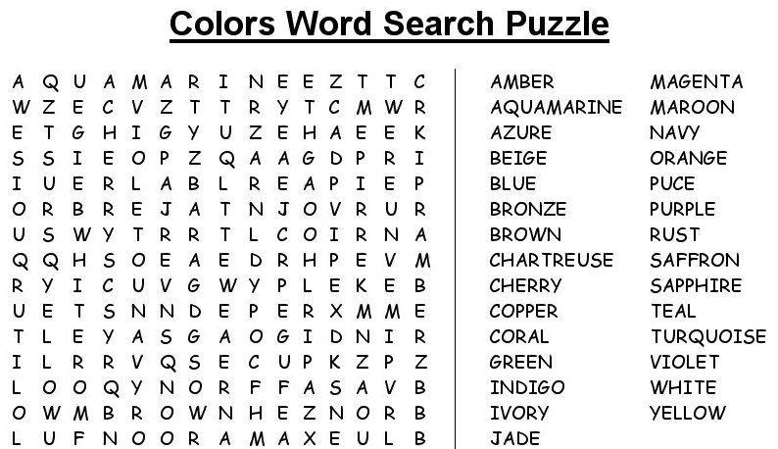

First year .. first term ..
T , Muna

