
Kingdom of Saudi Arabia English Language
Ministry of Education 6th Grade Elementary Almagdam Elementary School 2nd Term Exam
Date : Time: 45 m

Students Name:…………………………………………… class:……………….

: Listen then answer:  - Choose :     Some people ( walk / take the school bus ) to their jobs.   Some students ( walk / drive car ) to school .  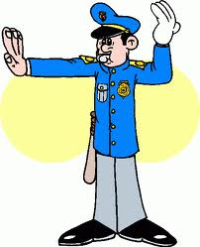   Early Monday ( afternoon / morning ) is usually busy.     ( Students / Police officers ) direct traffic in every corner.   ( Sun / Men ) usually rush to their jobs.   The city is ( Beirut / Paris ). | Be willing to listen to short prepared recorded materials.  Marks  ((3 Marks))

    Q : Answer :  - What is his nationality ?    ……………………………………………………………………………  - How much is it ?  …………………………………………………………………………………… | Write guided answers to written questions.  ((2 Marks ))

Q: Read:  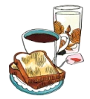    Ali is a good schoolboy. He is 12 years old. He wakes up in the morning. He prays AL Fajr. He eats his breakfast. He goes to school.  Q: Choose:   Ali is a ( teacher / schoolboy / doctor ).   In the morning, he prays ( Al Fajr / AL Asser / Al Maghreb)  Q: Complete:   He eats ………………………………………………   He wakes up in the ……………………………………………… | Be willing to read simplified illustrated (drawn/ pictured) children short stories.  ((4 marks))

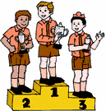  Q: Choose the correct sentence:  1- a- I am the First.  b- I is the First.  4- a- The tea are hot.  b- The tea is hot.  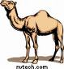  5- a- Camels am big.  b- Camels are big. | Describe simple events using verb to be.  (( 3 marks))

Q : Choose :  - My name is Hind ( ? / . )  - Can I go , please ( ? / . )  - ( Ali / ali ) is from Saudi Arabia .  - Hind is ( Omani / omani ).  Q : Choose :  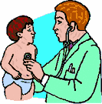  - Is it a book ? Yes , ( she is / they are / it is) . --    - Is he a doctor ? Yes , ( he / she / it ) is .  - Is ( he / she / it ) a teacher ? No , she is not .  - Are you a schoolgirl ? Yes , I ( you are – I am – we are ). | Recognize and use punctuation and capitalization assigned for the 6th elementary grade.  ((4 marks))  Recognize present simple tense (affirmative , negative & interrogative statements) and  Yes/No questions.  ((4 marks))

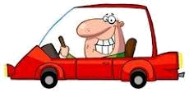  Q : Choose :  Ali  the car  - Where is Ali ?   Ali is in the car.     Ali is under the car.  the father  the mother  - Where is the mother ?   The mother is between the father.   The mother is next to the father | Recognize prepositions (time & place)  (( 2 marks)).

1 Copy the following in CURSIVE :  night family nose  orange pen queen | Copy words, numbers, and short sentences using cursive script.  (( 3 mark))

