
Unit (4 ) Lesson ( 1 )
My Name …………………………………………………………………………………………………………………………………………..

Q 1: Write the correct word under each picture :

( housewife -husband -born - dictionary- paints- married - ruler – raincoat )
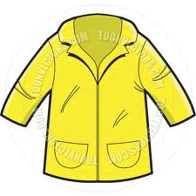
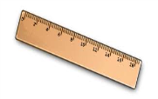
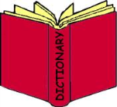



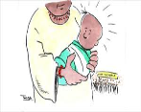

i

…….. ….….. …..… ……... ……… …….. …….. …….

Q 2: Complete :
Why do they need the …..…

( breakfast - sport )

- ………………………………………..……………… .1


2- …………………………………………………………...

Q3: Choose :
1- When ( was – did ) your last class ? .
2- When ( do – did ) they start the party ?


Mrs: Lamia

