*Name:………………………………………………………………………….. 4th………………….
لم تتقن | أتقنت | المهارة
 |  | -Recognize and apply the directionality in writing English (left/right, top/bottom
 |  | -Use lined paper correctly with headline, midline and baseline
 |  | -Write upper /lower case letters correctly
 |  | -Do controlled writing such as supplying missing letters and word
 |  | -Read and match words to photos/drawings

Trace:
.
***************************************************************************************************************************
Copy the following letters correctly using the four lines :
A a B b C c D d E e F f

****************************************************************************************************
Write the upper case letters of the following :

Write the lower case letters of the following :

********************************************************************************************************************
 | 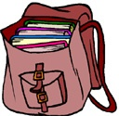 |  | 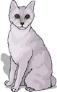
…….pple | …….ag | …….gg | …….at

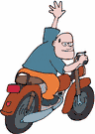Read the following words then match them to the correct picture: Count and write :

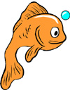
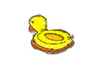



Good luck E.T : LoOove

