

The Final Exam for 2st Grade
Second Term
1435 - 1436 AH
Time: One Hours

المملكة العربية السعودية
وزارة التربية والتعليم
الإدارة العامة للتربية والتعليم بالرياض
مجمع الغطغط
الصف الثاني متوسط

 | Mansour Alziaidi | Corrected by
30 | Thirty marks | Total marks

الاسم /Name: …………………………………………………………………………………………………….........…………………….

Q.1 –Write a paragraph about yourself:

…………………………………………………………………………………………………………………………………………………………………………………………………………………………….………………………………………………………………………………………………………………………………………………….………………………………………………………………………………………………………………………………………………….…………………………………………………………………

Q-2 Read the passage and answer :

Airbus A380s are now the world's biggest planes. People call them "superjumbos", because they are even bigger than jumbo jets, they weigh 550 tones and are 72 meters long, 80 meters wide and 24 meters high, so they are even heavier, wide and taller than Boeing 747s. They can carry 550 passengers and fly at speed of 900 km/h.
A- Choose the correct answer:
1- The Airbus A380s weigh ...............
a- 550tones c- 540 tones d- 530 tones

2- The Airbus A380 can carry .................
a- 550 passengers b– 530 passengers c- 500 passengers

3- The speed of An Airbus A380 is ………..
a. 900km/h. b. 800km/h. c. 6 920km/h.

B. Put ( √ ) or ( X ) for each statement:
1- The Airbus A380s is taller than Beoing 747s. ( )
2- The Airbus A380 is 72meters long and 80 meters wide. ( )
3- The airbus A380s Fly at speed of 350km/h. ( )

Q3- Complete:
A. Put the verbs into the correct form (future I simple). Use will.
- I (earn)………..a lot of money.
- You (travel)………….around the world.
- You (meet)……………… lots of interesting people.
- Everybody (adore)…………you.
B. Fill in the correct reflexive pronouns.
myself - yourself - himself - herself - itself - ourselves - yourselves - themselves
1- Robert made this T-shirt ………….. .
2- Liza did the homework ……………. .
3- We helped ………….. to some cola at the party.
4- Sara, did you write this poem ……………….. ?
5- Yes, I wrote this poem …………. .
6- He cut …………………….. with the knife while he was doing the dishes.
7- The lion can defend …………………. .
8- My mother often talks to…………… in the kitchen.

Q4-

A. Write the correct word under each picture:
Classroom - Closet - Teacher - Jacket
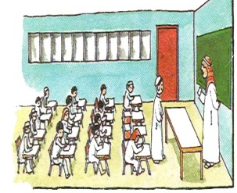
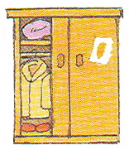
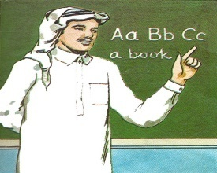
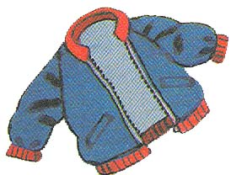

…………….…………………………
……………………………………
……………………………………
……………………………………

B . Copy the following sentence:
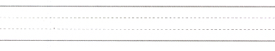
Everyone have to work hard to live a better life.

منصور الزيادي أعداد :

