Name ............................................................................ class:.........................





I he she we you

my his her our your
His
My
Your
Her
Our

Subject Pronouns
Possessive Pronouns

…… am Saudi
……… is Rana
……… is Omar
......... are a student
....... are friends

……………country is Saudi Arabi.
………………name is Rana
………………name is Omar
……………………coat is nice
…………………school is beautiful

She
I
He
We
You

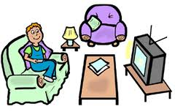
1-We are sisters
2- This is …………………living room

1- Is this ( you – your ) bed room ?
2- No, it's ( my - I ) bathroom .
3- ( We – Our ) garden is beautiful .
4- ( My - I ) bag is small.
5- This is Leen . This is ......... bed .
6- This is Ahmad . This is ......... pen .


1- He is Nader.
2-This is …………….... hair .


1- She is Layla .
2- This is .…………... chair

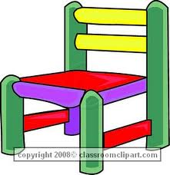

reorder the letters :

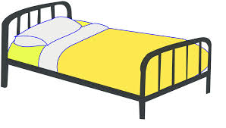
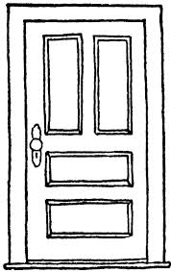

odro bde ouehs
................ .......... ..............

Name the correct objects :
1- This is a............. 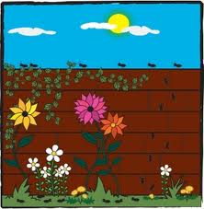
2- This is a ............. 
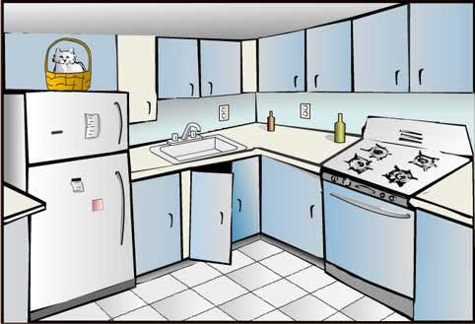

3- This is the .............

4-This is a...............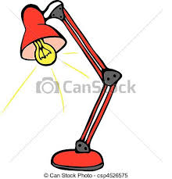

1- Is this ( you – your ) bed room ?
2- No, it's ( my - I ) bathroom .
3- ( We – Our ) garden is beautiful .
4- ( My - I ) bag is small.
5- This is Leen . This is ......... bed .
6- This is Ahmad . This is ......... pen .

1-What is your first name ?
…………………………………………

2-What is your last name ?
………………………………………………….………….
3- Where are you from ?
……………………………………………………………

Listen and number :

chair ( ) shop ( ) shoes ( ) teacher ( ) she ( )

