Wonderful words unit 5 celebrate
Name ______________________ class1/_____________

-Families gather together during Eid to a- play b-celebrate c-fight
- What are your favorite foods? My favorite foods are pizza and kabsa.

Circle the odd one:
- Eating drinking fasting
- First Charitable Ninth

Choose correct verbs :
- ( Not play – Don't play – No play ) with those boys.
- Don't ( is – are – be ) late for school.
- Jaber, please phone ( my – you – me) from the house.
- There is ( some – any ) food on the table.
- Is there ( some – any ) bread ?

Complete the the sentences with a , an , _ :
- We need …---….. money for the balloons.
- She want ……an…….. apple to eat.
- I read …a…. Book about Ramadhan.

Make a requests :
Borrow a pen ( Can I borrow apen.)
Use your computer ( Is it ok if I use your computer. )

Put the letters in correct order :
- Keca cake
- ath hat

put the correct word in correct column:
juice – book – pen – water – sugar - flowers

countable | uncountable

pen juice
book sugar
flowers water

Write the words under the pictures .
  Balloons |   money |   presents | 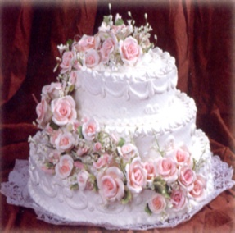  cake

Copy this sentence :

Ramadhan is the ninth month in Islamic calendar.

----------------------------------------------------------------------------------------------------------------------------------------------------------------------------------------------------------------------------
_________________________________________________________________________

Study hard dear students
Your teacher
Badoor

