Name......................................................... 3rd Unit 2+3
Q1)Grammar
A – Circle the correct answer:_
1- Is there ( a - an - the )dishwasher in your kitchen?.
2- ( who's – whose – what ) mobile is this ?
3- He ( starts – start ) work ( in – on – at ) 8:30 every morning.
4- (Are there – is there )two bedrooms in your flat?
5- Beth wants to (go – going ) to the bath.
6- Tom( is playing- plays ) football now.
7- There's John and phil. I can see ( theirs – their- his ) car.
8- Daniel ( never is – is never ) late for school.
9- Rob and I ( do – does ) kickboxing.
B: Do as shown in the brackets;-
1-in / evening/ cooks / he /dinner / the . {Put the words in correct order}.
…………………………………………………………………………..
2There is a bank near here. { Make Yes/No Question }
…………………………………………………………………………
Q2: Vocabulary:
A- Circle the correct word :
1-The lamp is ( in – between ) the sofa and the armchair.
2- My ( nephew- uncle ) Ahmad is my sister's son.
3-My car is in the ( garage – balcony ).
4- What's that ( under – behind ) the rug.

B: Match the word with it picture :
4-sunny | 3- snowing | 2- mop the floor | 1-chef
8-bellboy | 7-car park | 6- drawer | 5-fridge
12-raining | 11- washing-machine | 10- library | 9- reporter

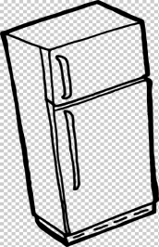 |  |  | 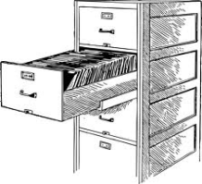
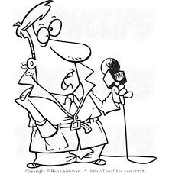 |  | 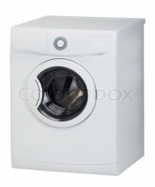 | 
 |  | 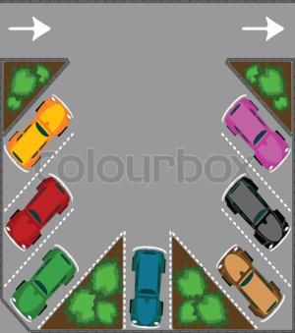 | 

End of the Questions .

