**Revision Unit4..Culture old and new** 3rd grade secondary

**1: Writing :** **Write an essay about a memorable trip in the past.. use the given questions :**

[ Where did you go ? – When was it ? – How old were you ? – What happened first and later ? – How did you feel ? – What happened in the end ?]

------------------------------------------------------------------------------------------------------------------------------------------------------------------------------------------------------------------------------------------------------------------------------------------------------------------------------------------------------------------------------------------------------------------------------------------------------------------------------------------------------------------------------------------------------------------------------------------------------------------------------------------------------------------------------------------------------------------------------------------------------------------------------------------------------------------------------------------------------------------------------------------------------------------------------------------------------------------------------------------------------------------------------------------------------------------------------------------------------------------------------------------------------------------------------------------------------------------------------------------------------------------------------------------------------------------------------------------------------------------------------------------------------------------------------------------------------------------------------------------------------------------------------------------------------------------------------------------------------------------------------------------------------------------------------------

**2: Choose the correct word under the pictures :**

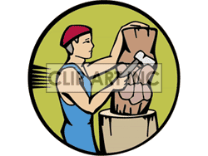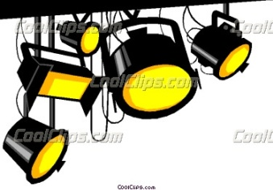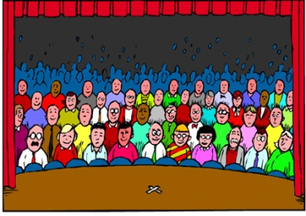

a-(audience – performance ) b-( scenery – lighting ) c-( textiles – drawing ) d-( wood carving- stage )

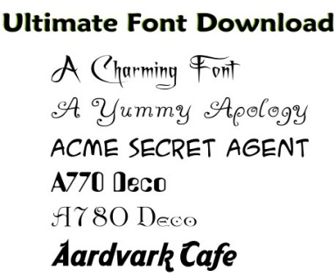

e-( calligraphy – abstract painting )

**3: Choose the correct answer :**

a- The American **( architect – architecture )** Adrin Smith designed Burj Khalifa Building

b- The letters are so beautiful , he writes like a **( calligraphy – calligrapher )**

c- He is a **( story teller – storytelling )** , he ( tells- telling ) wonderful stories .

**4- Complete :** --------------------------------- is a Saudi poet. He wrote many poems . His poem ---------------------------------------------------------------------- is my favorite one .

5-

**Reported Speech** : we change the pronouns and the verb tense

Present simple Past simple Present continuous  past continuous

Present perfectpast perfect past simple past perfect willwould

Can could may might must / have tohad to

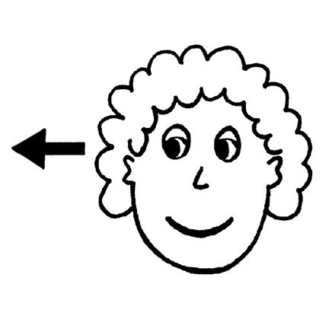

**Change from direct speech to reported speech :**

a- “ I have tried to teach my children “

He told me that ------------------------------------------------------------------------------------

b- “ It isn’t enough for me to live on “

He told me that ------------------------------------------------------------------------------------

c- “ I learned wood work from my father “

He told me that -----------------------------------------------------------------------------------

 d- “ I can repay everyone for their kindness “

He told me that ----------------------------------------------------------------------------------

6-

**Adjectives ending in** : **-ing** and **-ed**

Adjectives ending on –ed describe how somebody feels

**Choose the correct adjectives :**

a- Aren’t you **( tired – tiring )** ? you’ve been studying all the day

b- Many people are **( confusing – confused )** when they see abstract painting

c- The quality of the crafts is **( amazed – amazing )**

d- Samar says that reading her poetry aloud is **( embarrassing – embarrassed )**

7-

**Reported speech – questions :**

We change the tenses and pronouns

We don’t use auxiliary

We put **the subject** before **the verb**

We use **If** or **whether** , when there is no question word



**a- Change from direct speech to reported speech :**

1- “ Did you enjoy visiting you friend ? “

He asked me ------------------------------------------------------------------------------------

2- “ Will you recommended the castle to other people ? “

He asked me ------------------------------------------------------------------------------------

3- “ Are you going to travel to Makkah ?”

He asked me ------------------------------------------------------------------------------------

4- “Have you ever been to Riyadh before ?”

He asked me ------------------------------------------------------------------------------------

**b-Choose the correct alternative :**

1- “ Where are you from ?”

He asked me **[ Where was he from – where he was from ]**

2- “ Do you know how much damage caused ?”

He asked if **[ he did know – he knew ] how much damage he [ caused – had caused ]**

8-

**Reported speech- commands**

To + infinitive

**Negative :** not + to + infinitive

**Change from direct speech to reported speech :**

a- “ Speak clearly “

The teacher asked the student--------------------------------------------------------------

b- “ Do’t shout “

The mom told him ----------------------------------------------------------------------------

c- “ please stand up “

The policeman asked him --------------------------------------------------------------------

**9- fill in the spaced with the correct words , then answer the given questions below:**

 [ categories – contact – December 1st – December 10th – read – shy ]

**A great poetry competition**

Sunday --------------------------- in the school hall .

Have you got talent for writing poetry ? Could you ------------------ it at our poetry competition ?

Don’t be ---------------------- ! we need poems for the competition and people to read them !

There are three ------------------------------:

[ History , religion and the natural world ]

Send us samples for your original work by ------------------------------

There will be prizes for the best poems in each category .

For more information , ---------------------------------Fatmah on 054345678

a- What is the event ? --------------------------------------------------------------------------------

b- When is the event ? -------------------------------------------------------------------------------

c- Can you win anything if you participate ? ---------------------------------------------------------

d- What should you do if you want to know more ? -------------------------------------------------

e- What are the categories ? ------------------------------------------------------------------------

d- What kind of writing is this piece of paper ? ----------------------------------------------------

Prepared by

Teacher.. Bushra Assiri