**Unit ( 2 ) Lesson ( 3 ) Work paper ( 4 )**

**Choose the correct answer of the following :**

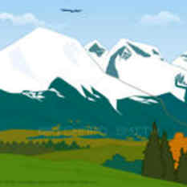1 – Mount Everest measures 8,848 meters high , mount kang measures 8,596 m . h , and mount Gargo measures 8,611 m .h .

* Mount Everest is the highest mountain .
* Mount kang is the highest one .
* Mount Gargo is the lowest mountain .



2 – Anne is 43 years old , Lynne is 40 years old .

* Anne is younger than Lynne .
* Lynne is older than Anne .
* 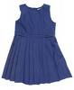Anne is older than Lynne .

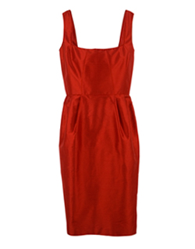

3 – The red dress costs 25,00 $ , the blue dress costs 15,00 $ .

* The red dress costs less than the blue dress .
* The blue dress costs less than the red dress .
* The blue dress costs more than the red dress .

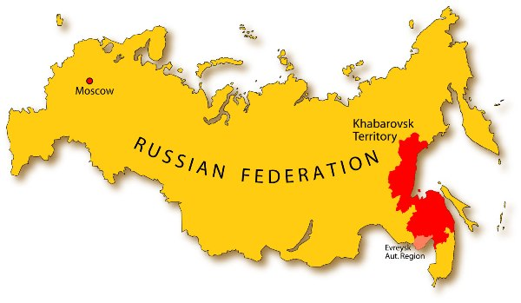4 – Russia is 17,075,000 sqm , France is 544,000 sqm .

* France is larger than Russia .
* Russia is larger than France .
* 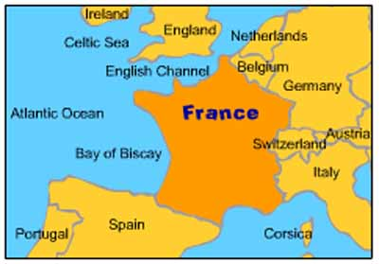Russia is smaller than France .

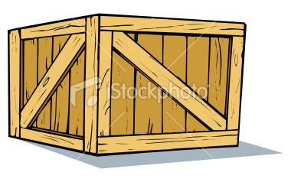5 – Box A is bigger than box B , box C is bigger than box A

* Box B is the smaller box .
* Box A is the biggest box .
* Box C is the smallest box .

6 – Jane has 1,633,20 , Bill has 1,635,30 , Jhon has 1,632,10

* Bill has the most money .
* Jane has the last money .
* Jhon has the most money .



7 – Carrots are good for you , Cakes are bad for you .

* 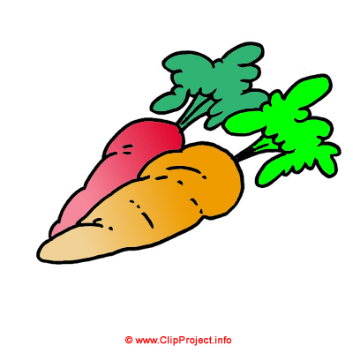Carrots are worse for you than cakes .
* Cakes are better for you than carrots .
* Carrots are better for you than cakes .

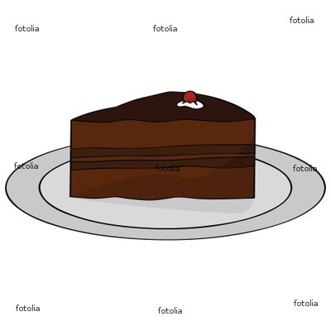

8 – Ahmed is taller than Jamal , Omar is taller than Ahmed .

* Jamal is the tallest one of the three .
* Ahmed is the shortest one .
* Omer is the tallest one of them .