**Unit (2) Lesson (2) Work paper**  **(1)**

**Participial Adjectives**

Complete each sentences using words from the box below

amusing/amused annoying/annoyed boring/bored

confusing/confused disgusting/disgusted exciting/excited

exhausting/ exhausted interesting/interested

He



1. I have got nothing to do . I'm …………………………… .
2. 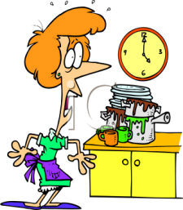The teacher's explanation was ………………………... , most of the students didn't understand it .
3. The kitchen hadn't been cleaned for ages . It was really ……………………………….. .
4. I visit art galleries although that I'm not ………………………….. in art .
5. There's no need to get ……………………… just because I'm few minutes late .
6. 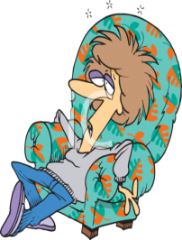The lecture was ……………………. , I fell asleep .
7. I've been working very hard all day and now I'm very ……………………………. .
8. I am starting a new job next week , I'm …………….
9. Steve is very good at telling funny stories . He is very ………………………….. .
10. Liz is an ………………………. Person , she knows a lot .