**Unit (2) Lesson (2) Work paper (2)**

**Talking about the future**

Complete the sentences using ( will / going to / might ) :

1 – (go)

" Anna is in the hospital "

" Oh really ? I didn't know ……………………….. and visit her

" Yes , I know …………………………………. Visit her this evening .

2 – ( rain )

 " Look at those black clouds , I think ………………………………………

 ………………….. .

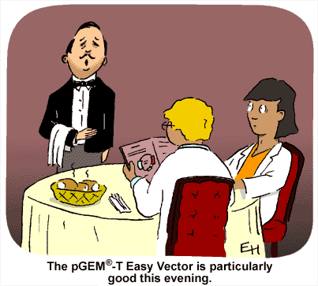

3 – ( have )

" What would you like to eat ? "

"……………………………… a sandwich ,

I don't know yet !! "



4 – ( lend )

" Oh , I forget my wallet !!

" Well , don’t worry ………………………………………. You some money .

5 - (invite)

Let's have

a party .

That's a great idea .

…………………………… lots of people .



6 – ( like )

"Tomorrow is Sarah's birthday , isn't it ?"

" Yes , and I think Sarah ………………………………

the present that I bought for her .

_______________________________

Name :

Class :